**Collection Framework Assignment**

[**Q1**](https://adapt.in.capgemini.com/mod/vpl/view.php?id=2148)**. Write a class Person having weight, height & name. Create multiple person objects & print them in the sorted order. In the sorting order first sort based upon their weight & it two persons have same weight them sort them based upon their height. Use TreeSet.**

**Description:-**

Create Person class with variables weight and height.Create multiple person objects & print them in the sorted order based upon weight first if the weights are equal then based upon height. Use TreeSet

Code:

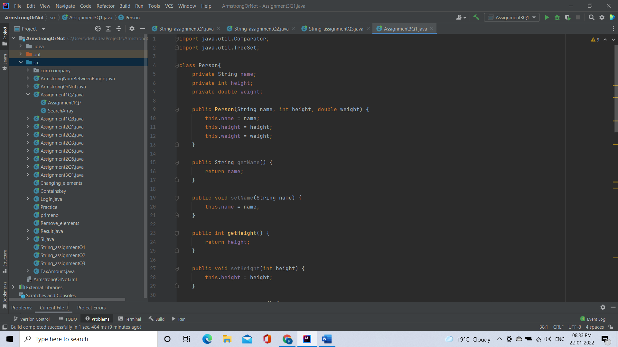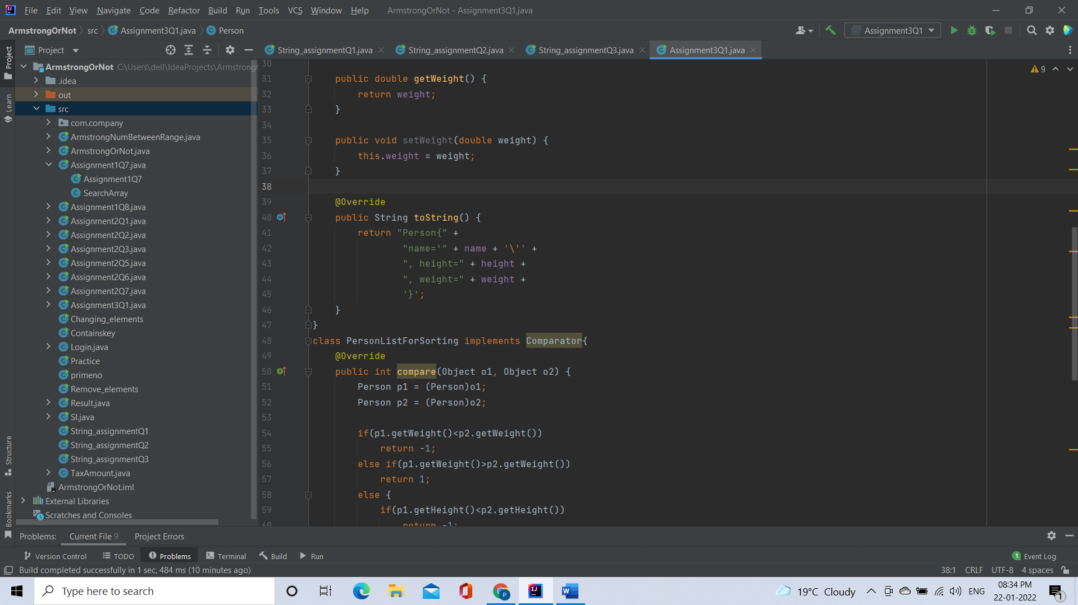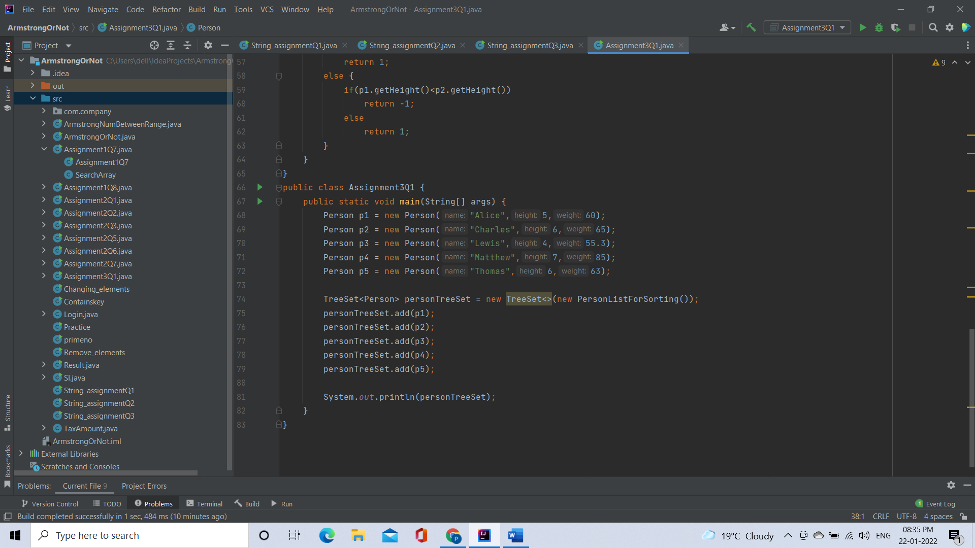

Output:

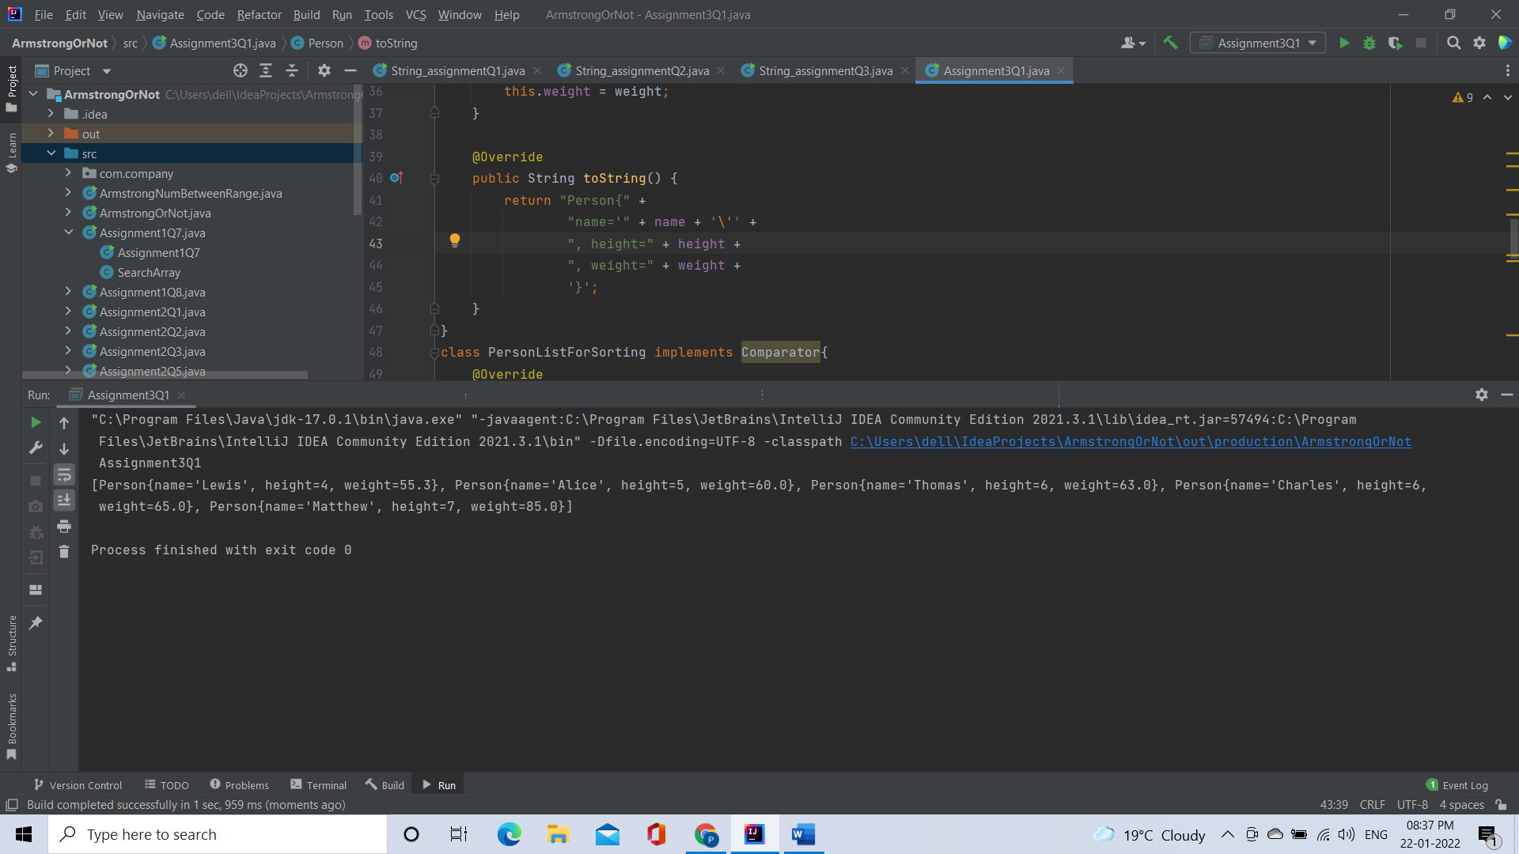

[**Q2**](https://adapt.in.capgemini.com/mod/vpl/view.php?id=2156)**.  Prove that Hash Set is unordered & Linked Hash Set is ordered.**

**Code:**

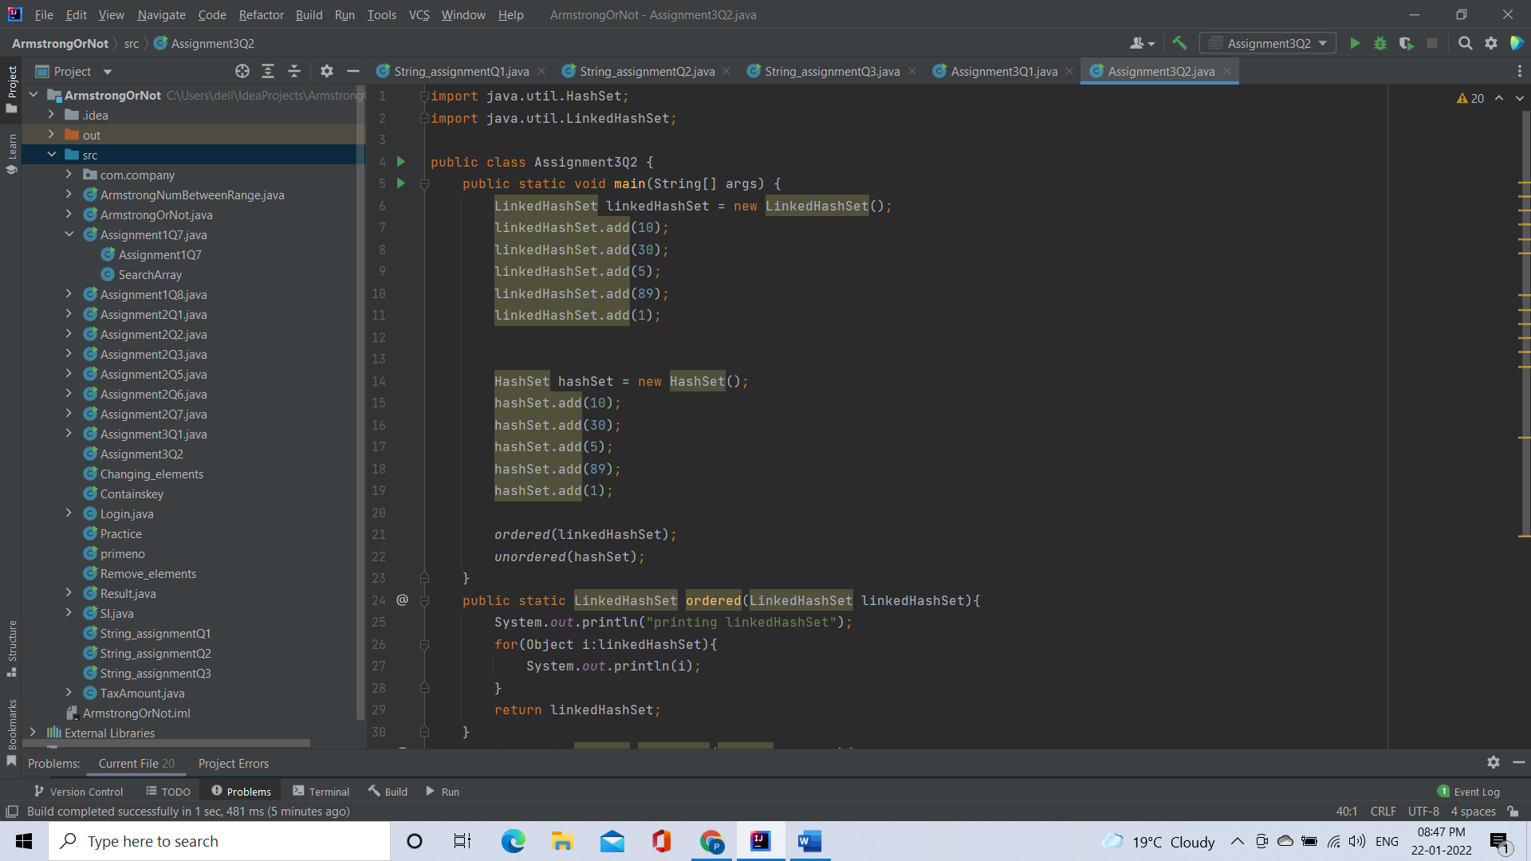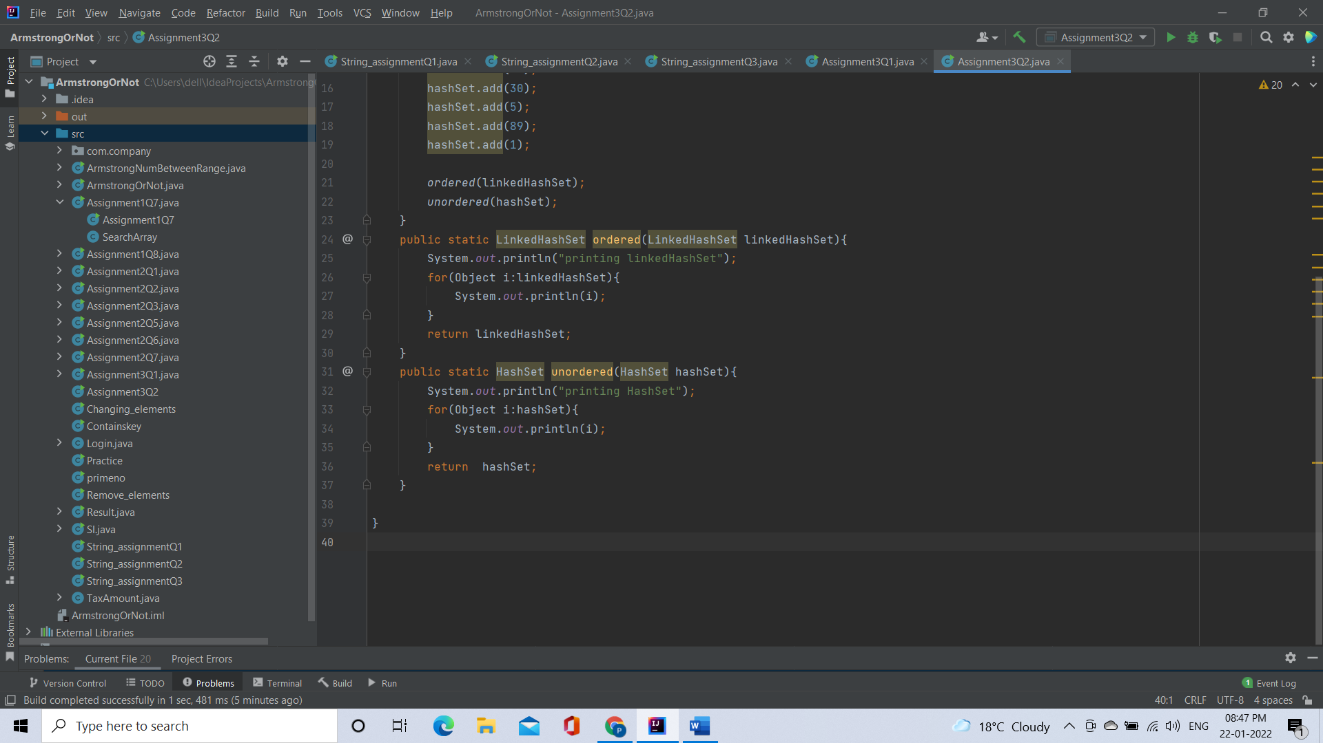

Code:

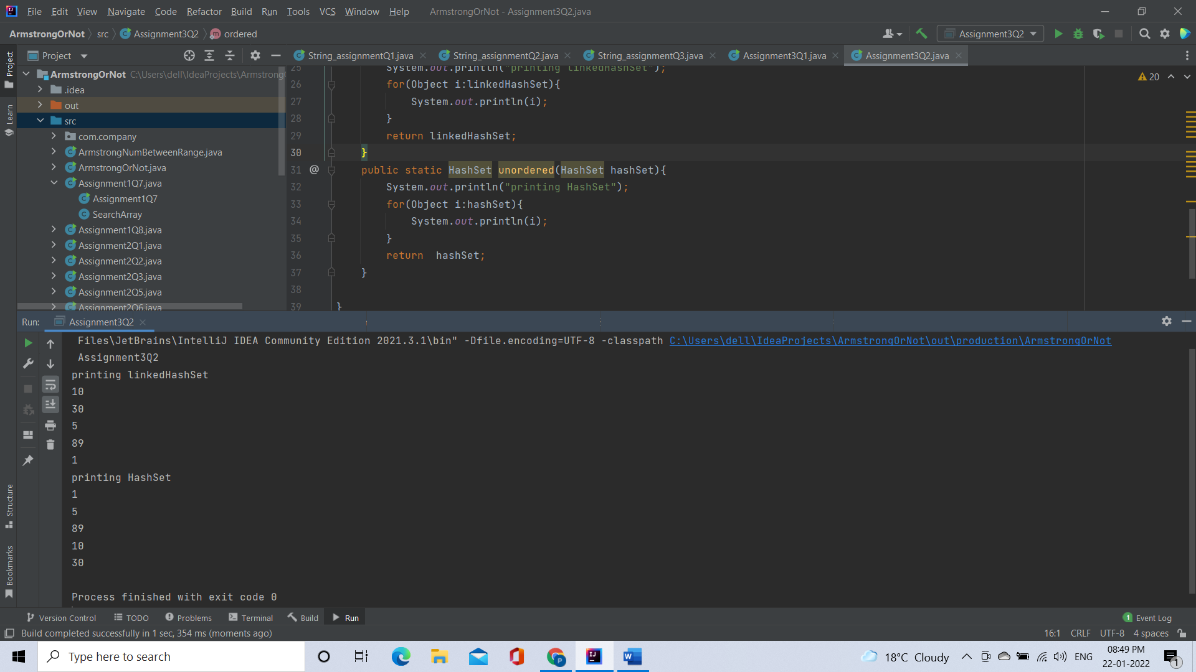

[**Q3**](https://adapt.in.capgemini.com/mod/vpl/view.php?id=2261)**. Create a ArrayList with few elements & print it in backward direction. Use ListIterator.**

**Description:**

Write a program which consists of ArrayList which has some elements and print them in reverse direction

Code:

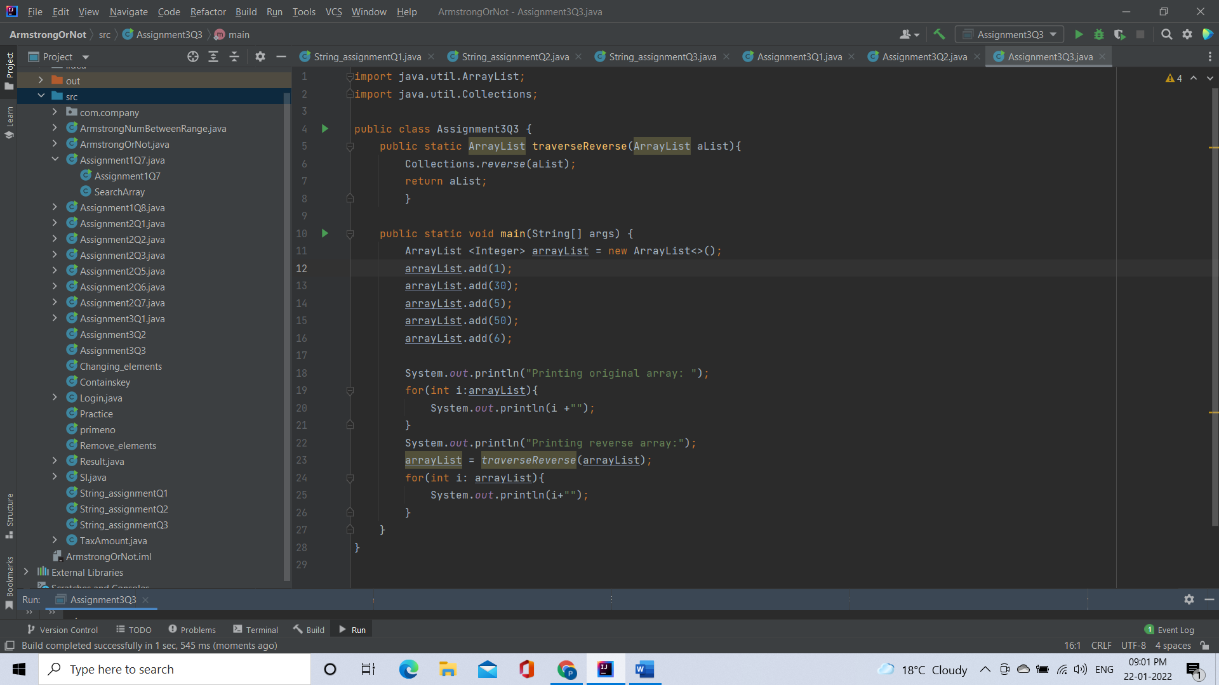

Output:

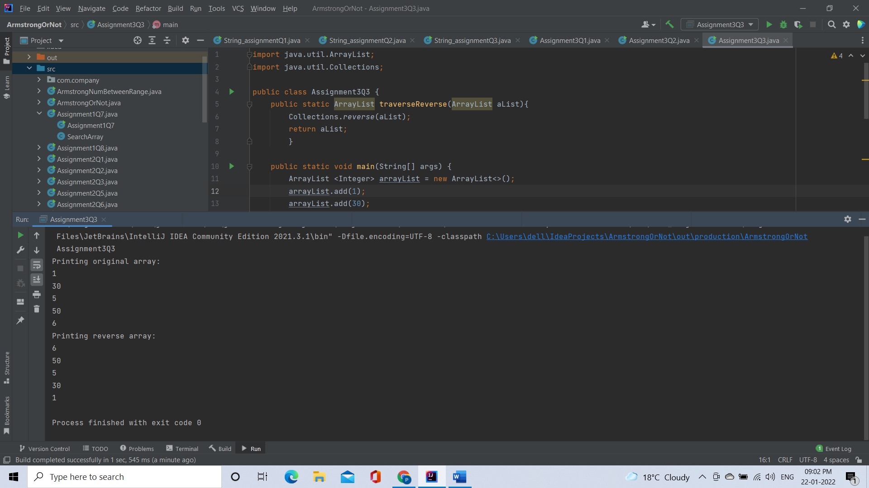

[**Q4**](https://adapt.in.capgemini.com/mod/vpl/view.php?id=2262)**. Write a program using Hashtable or HashMap where Date of birth is a key & Employee name as value. Design the class Date is such a way where the get method fails if two employees have same day & month of birth but birth year is different**.

Code:

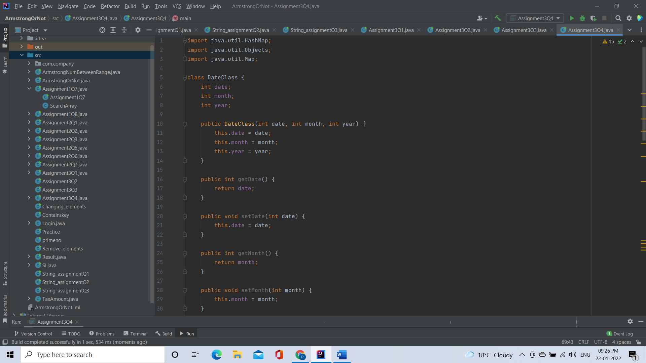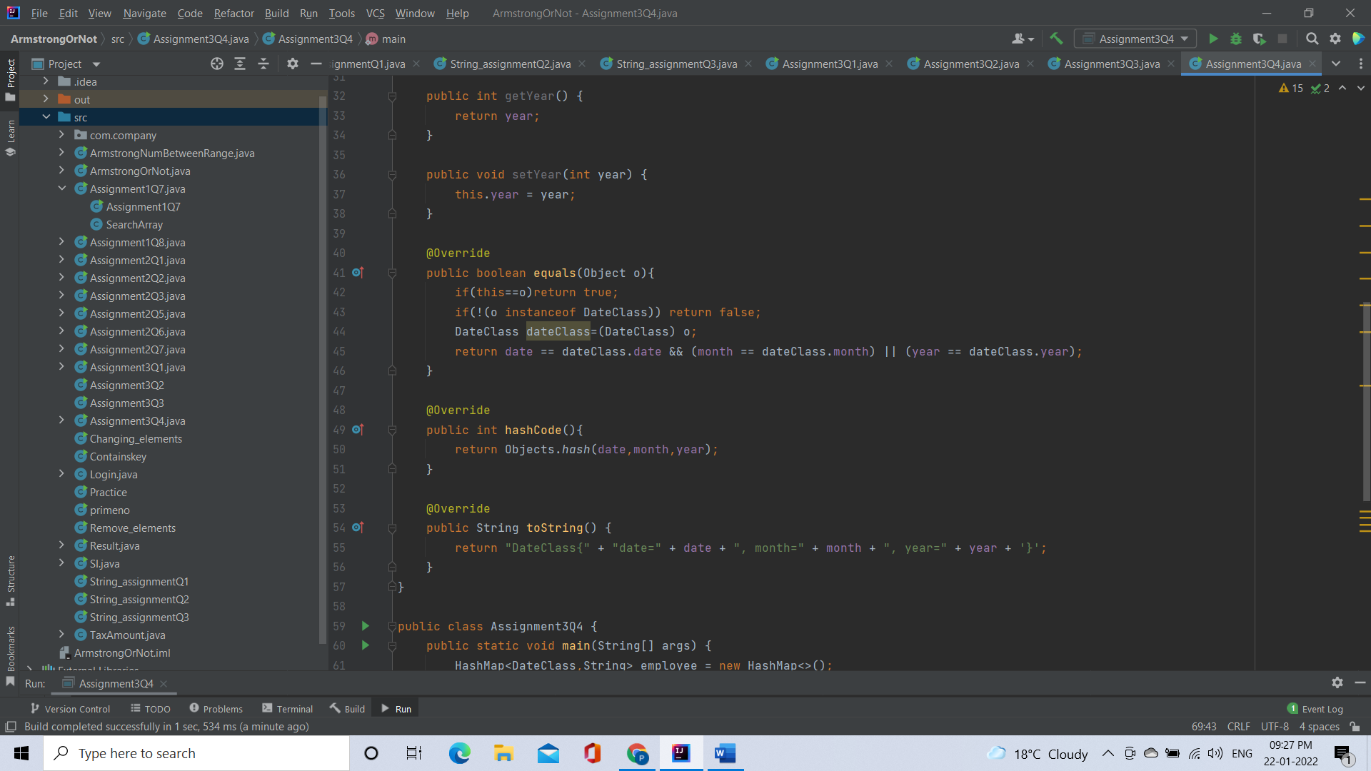

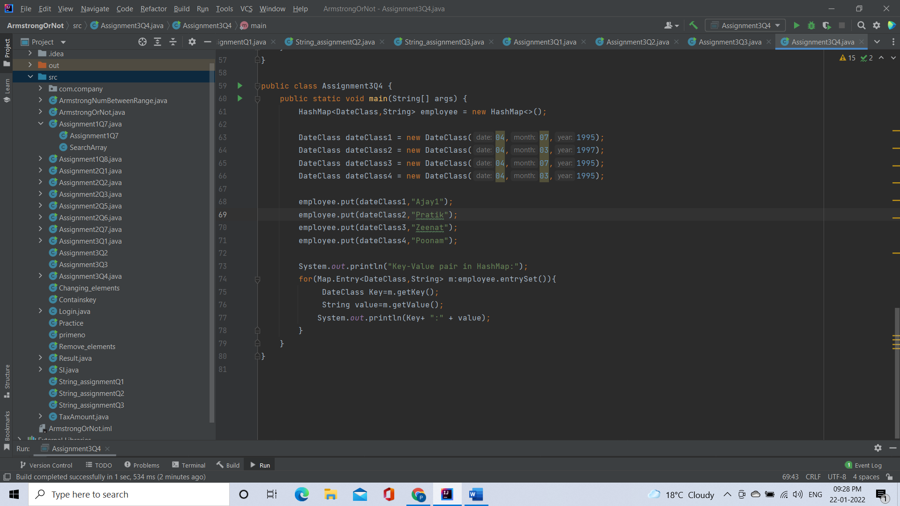

Output:

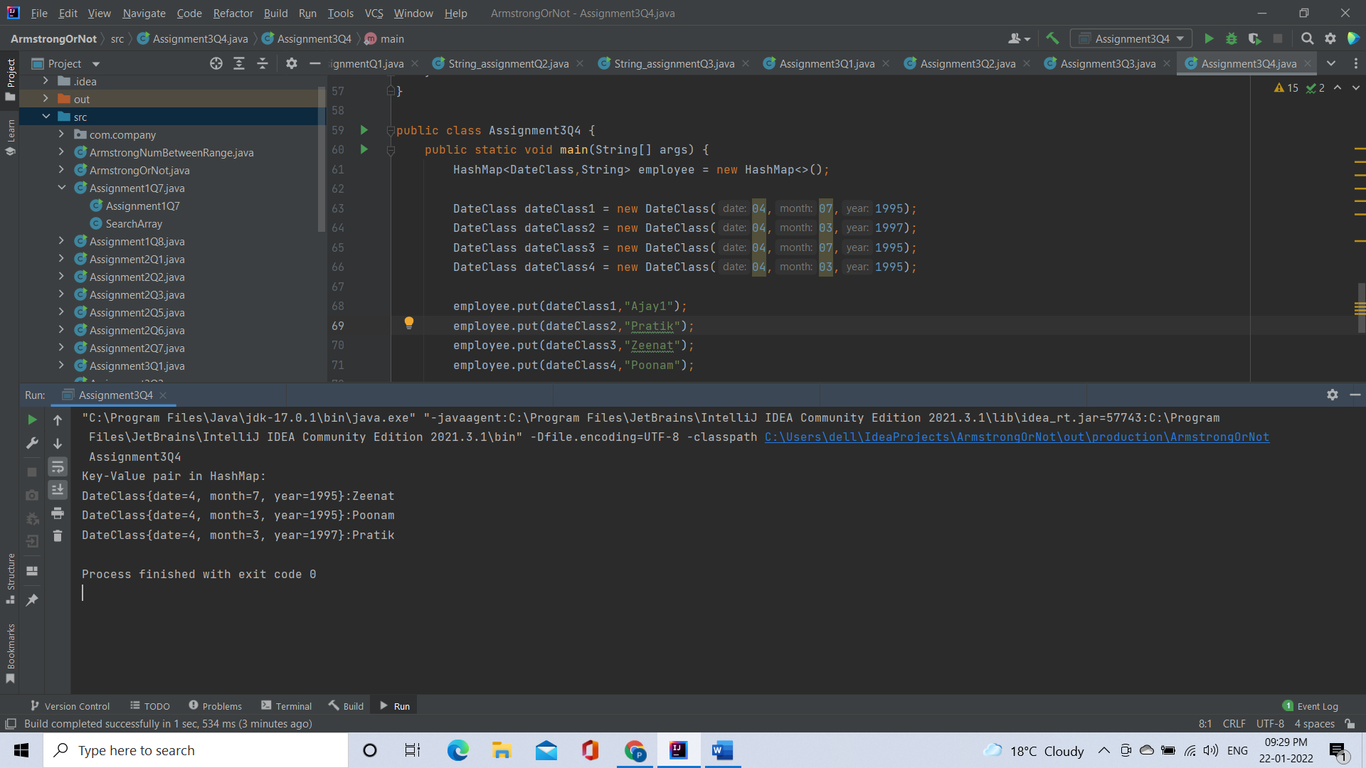

[**Q5**](https://adapt.in.capgemini.com/mod/vpl/view.php?id=2153)**. Write a user defined class say Employee that overrides equals() & hashCode() methods. Equals() always returns true & hashCode() always returns a fixed number. Make such a class as key of you Hashtable. Observe the behavior while calling put & get methods**

**Code:**

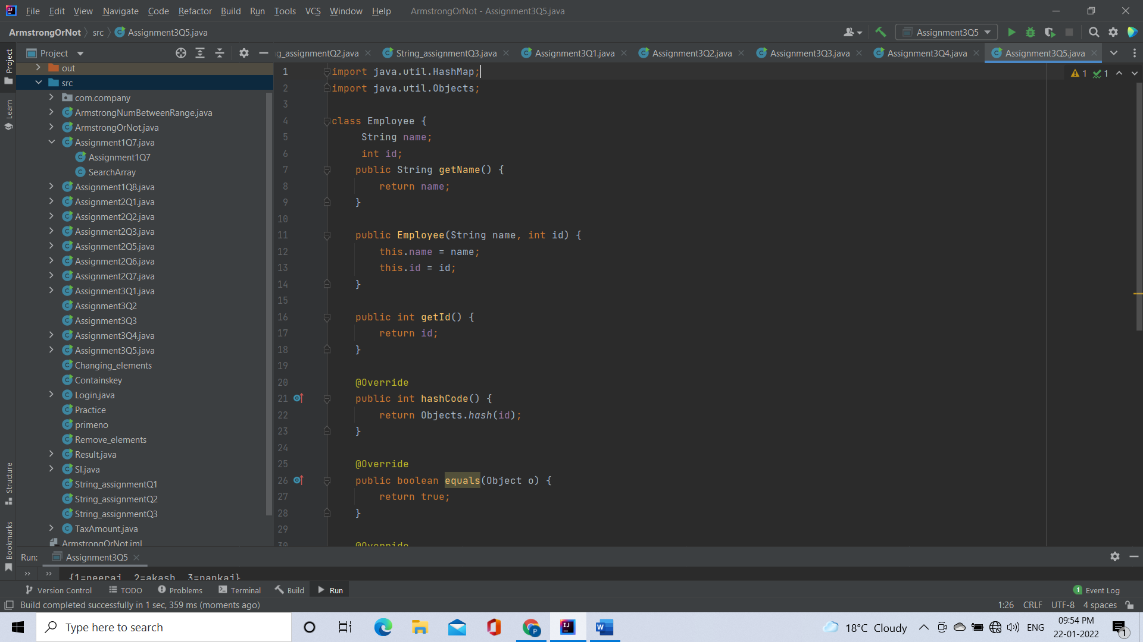

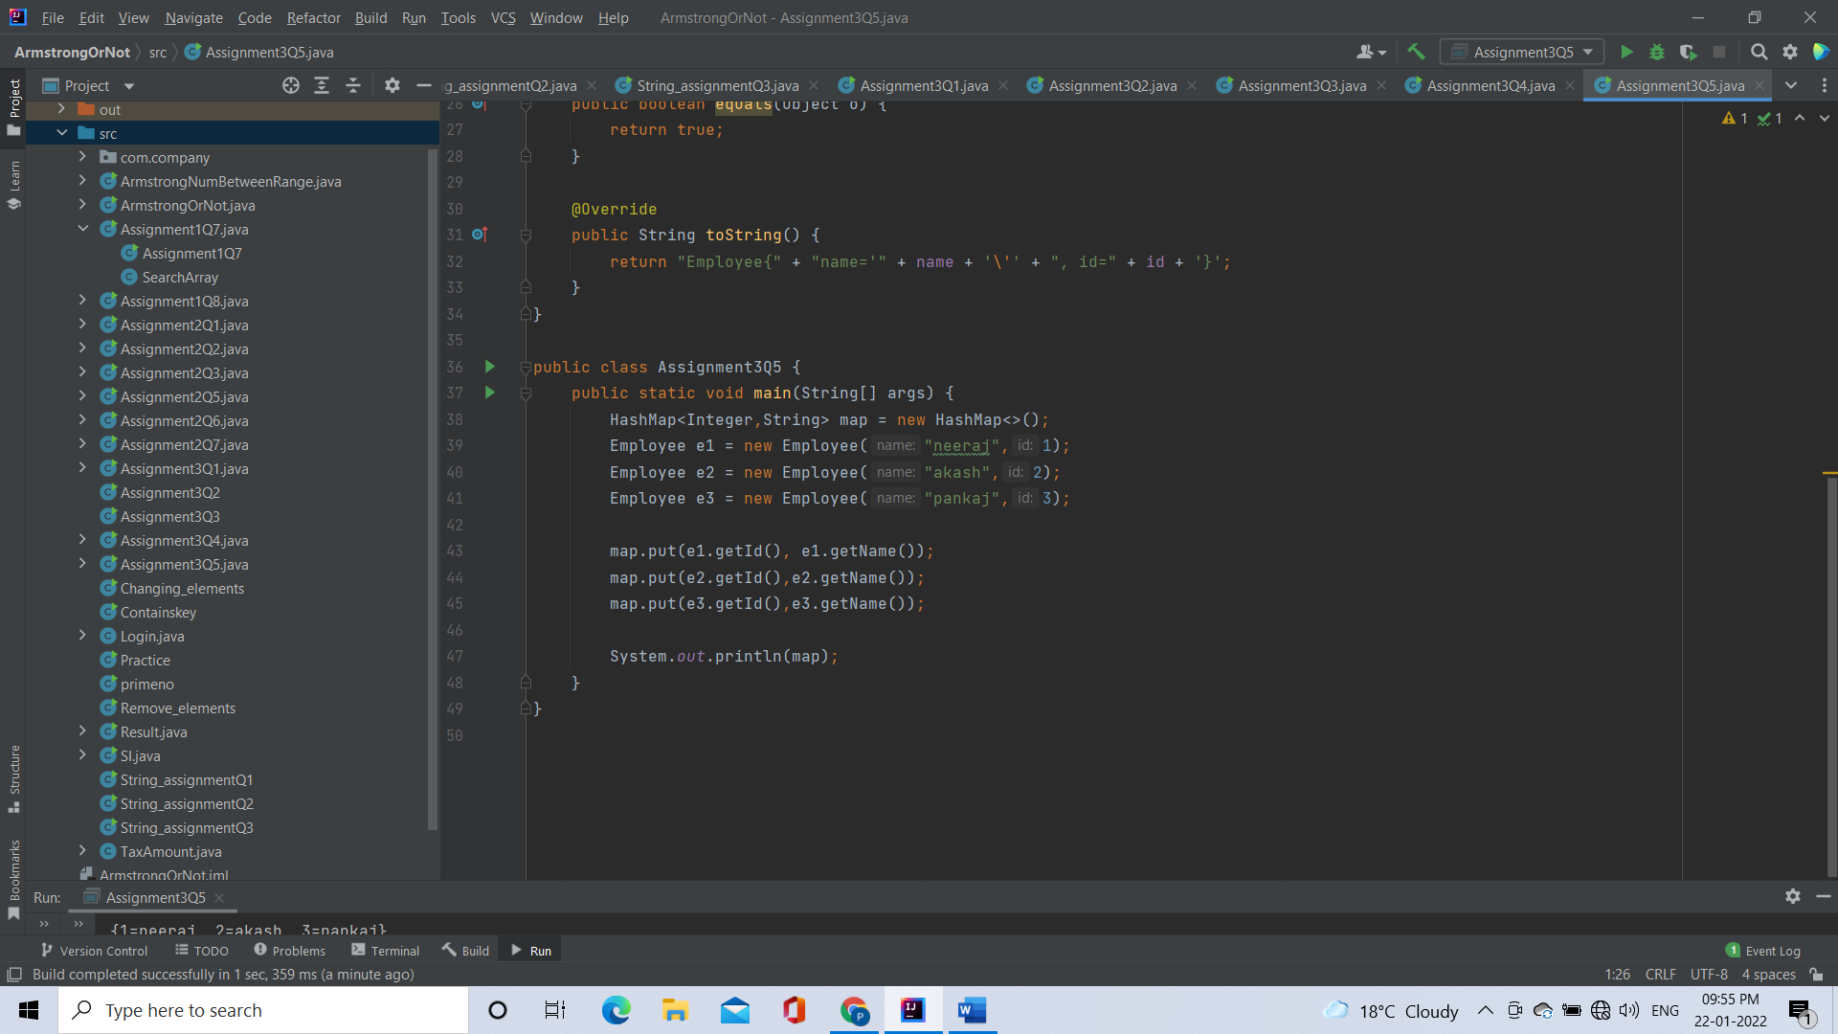

Output:

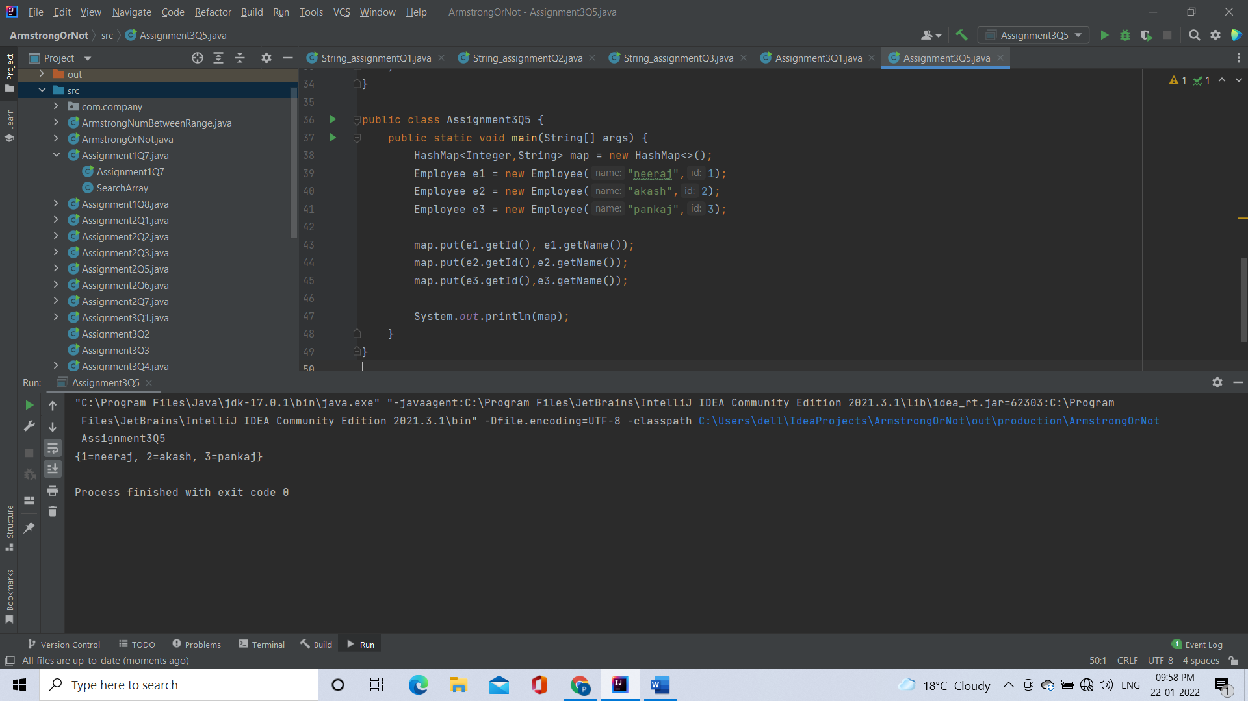

[**Q6**](https://adapt.in.capgemini.com/mod/vpl/view.php?id=2145)**. Implement the console based chatting using collections. Here are the options to be placed for to the user:**

**>java ChatApplication**

**Options:**

**A) Create a chatroom**

**B) Add the user**

**C) User login**

**D) Send a message**

**E) Display the messages from a specific chatroom**

**F) List down all users belonging to the specified chat room.**

**G) Logout**

**H) Delete an user**

**I) Delete the chat room.**

**Please enter your option:**

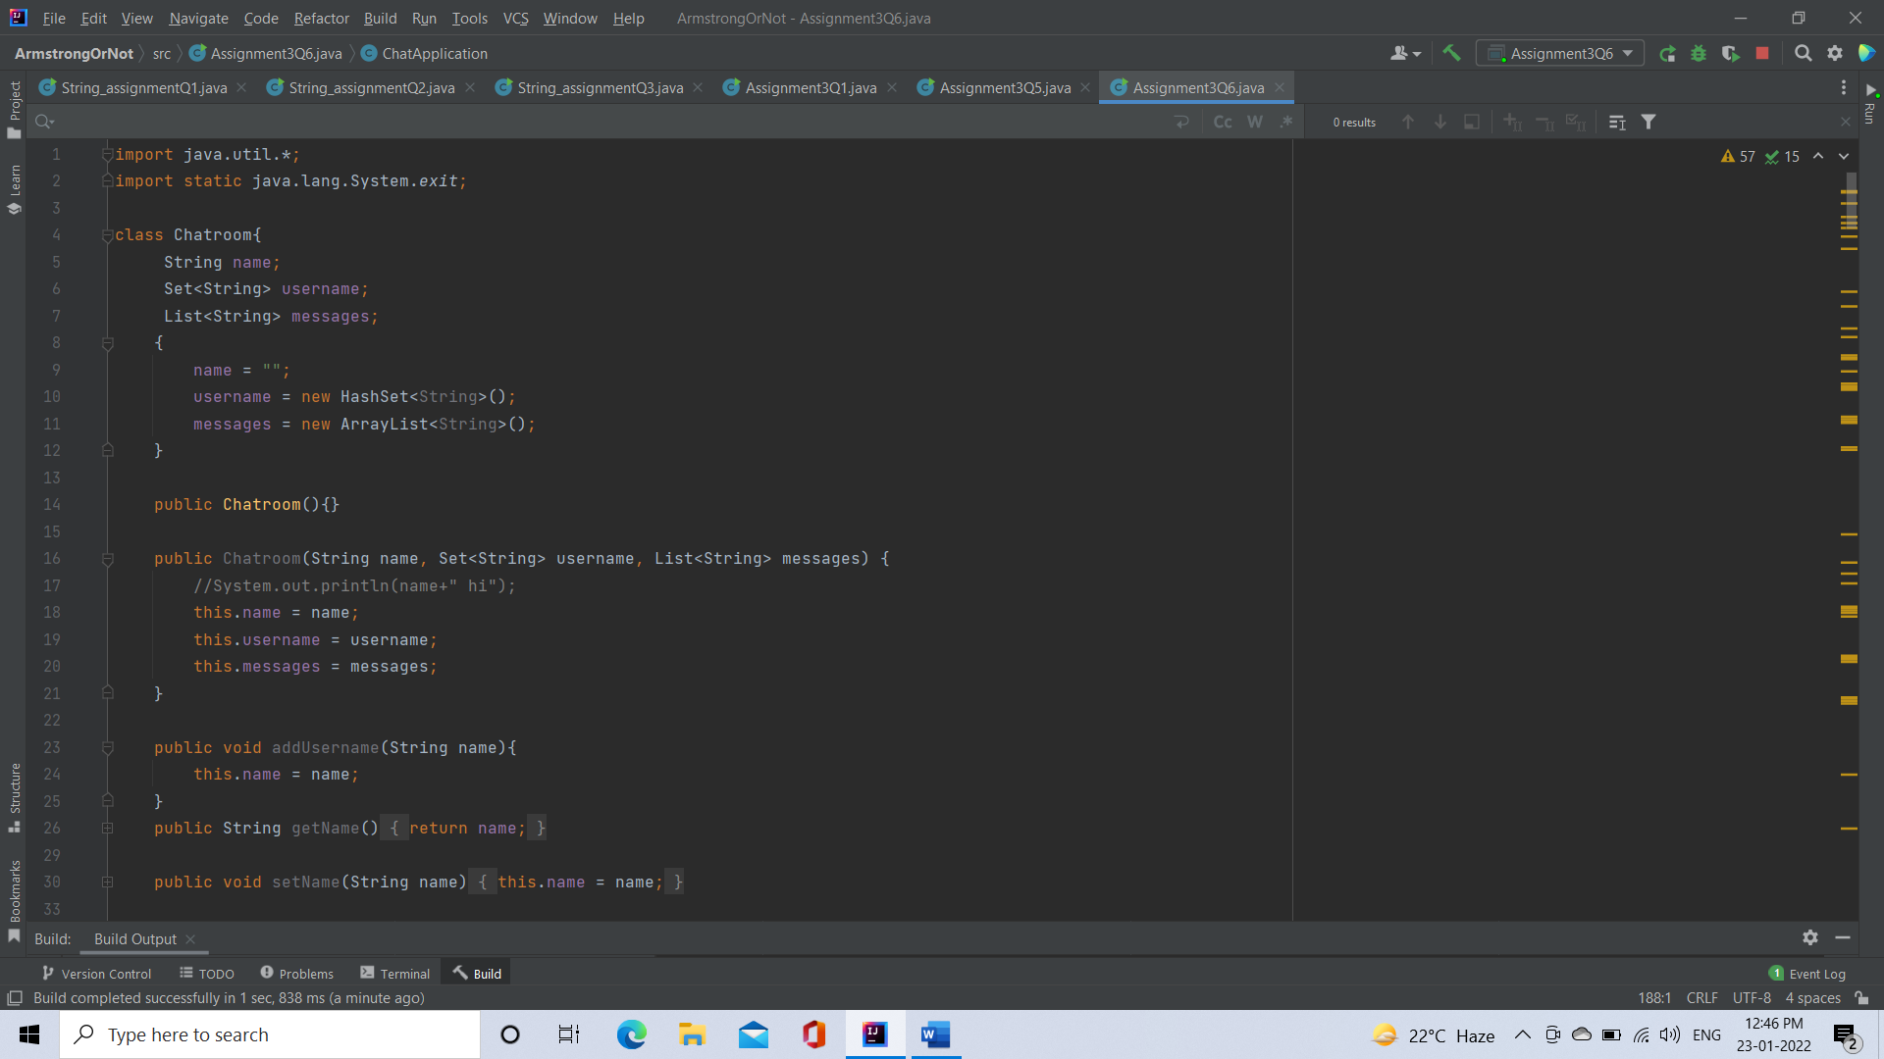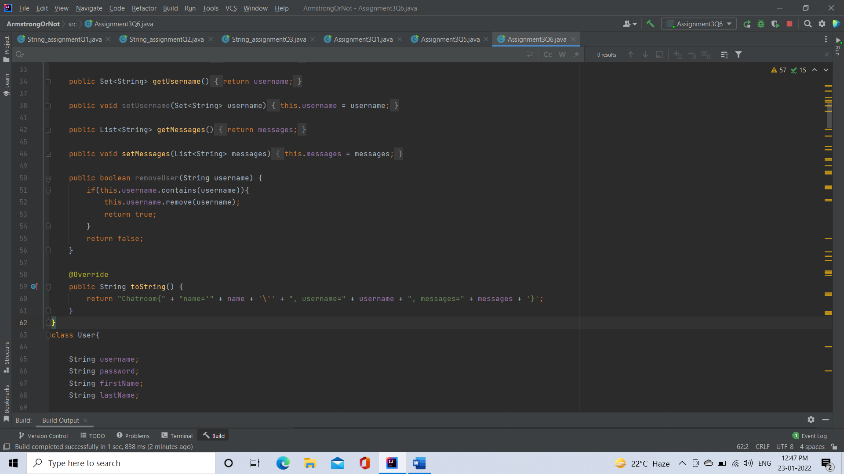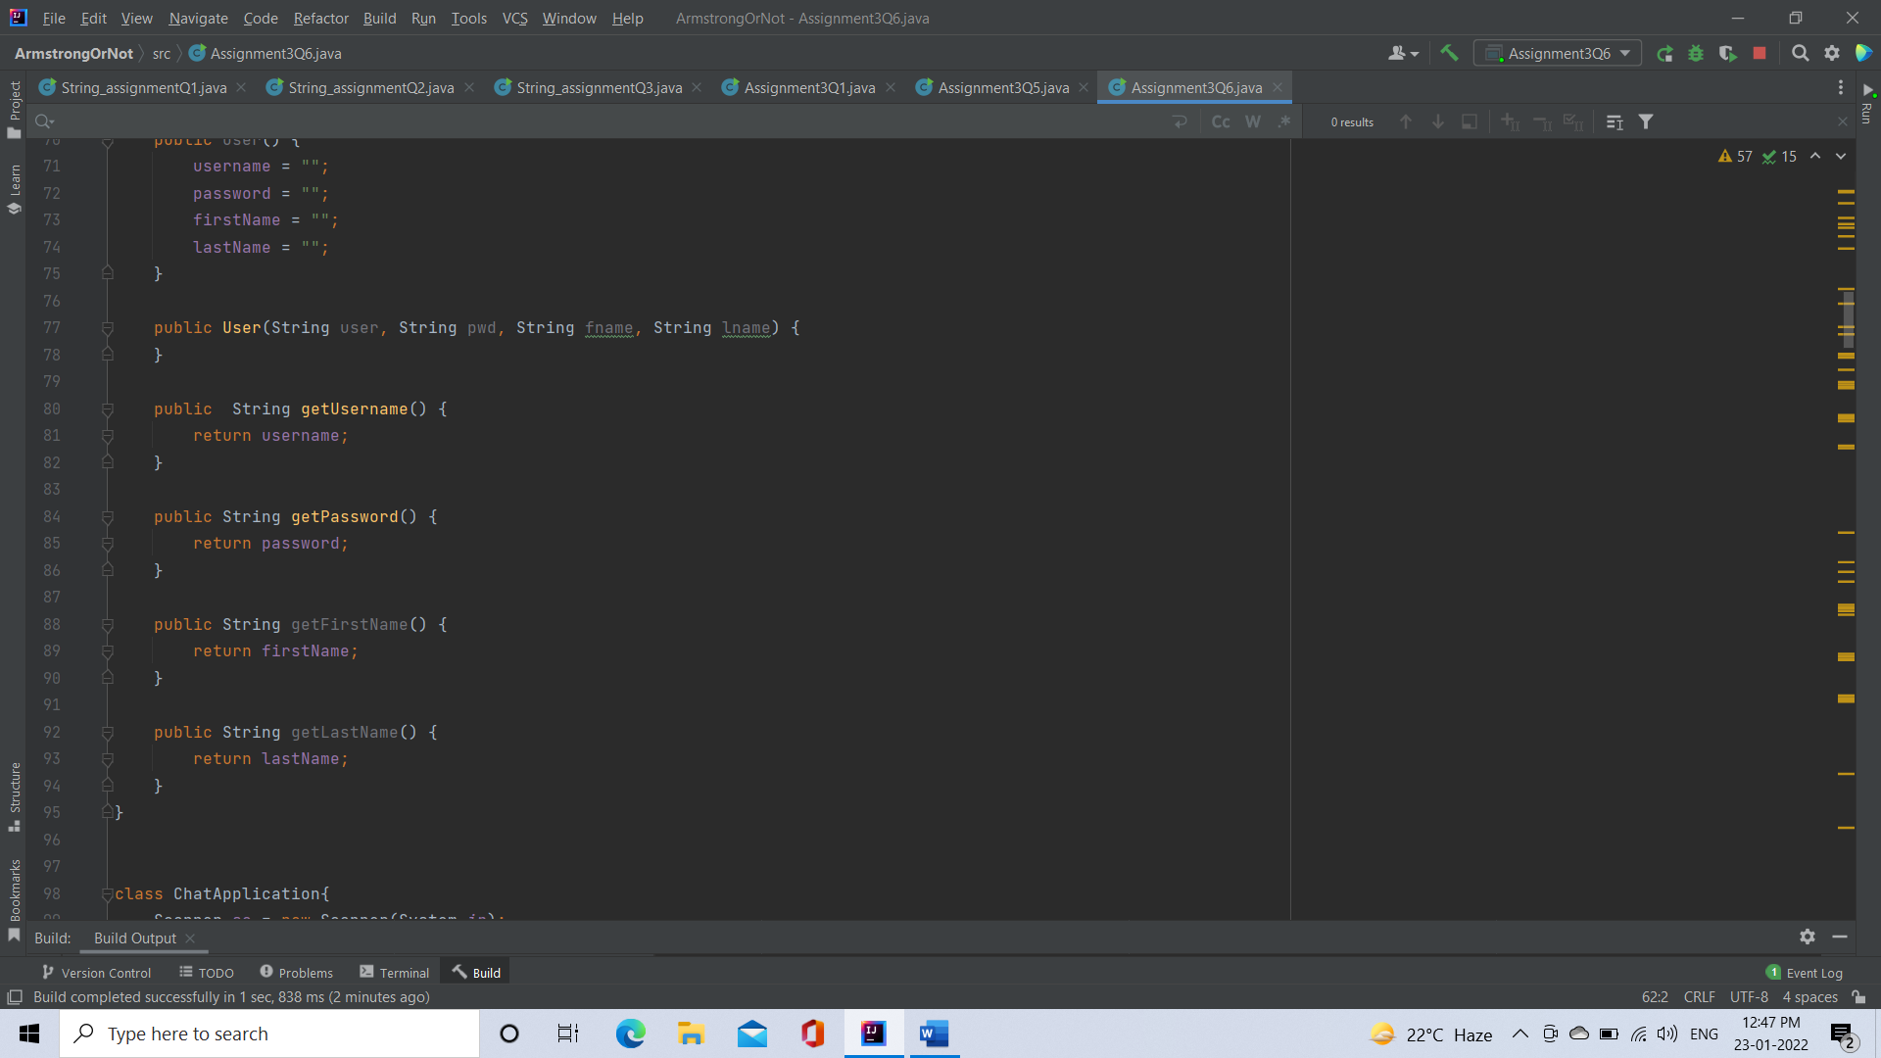

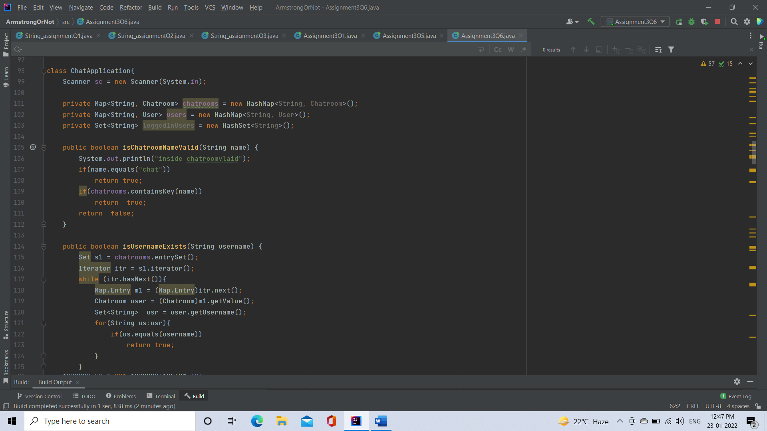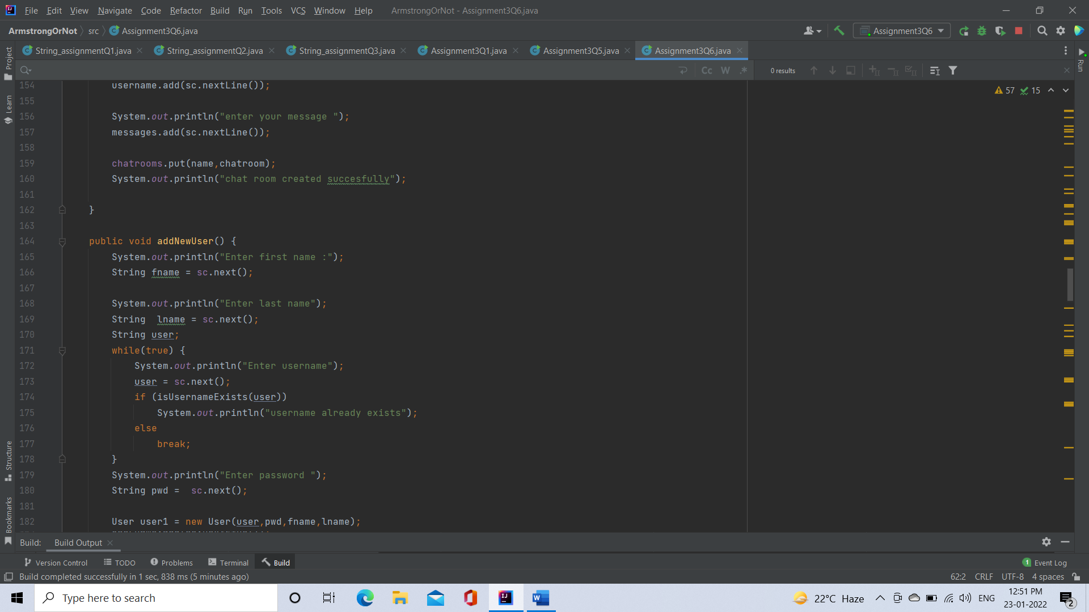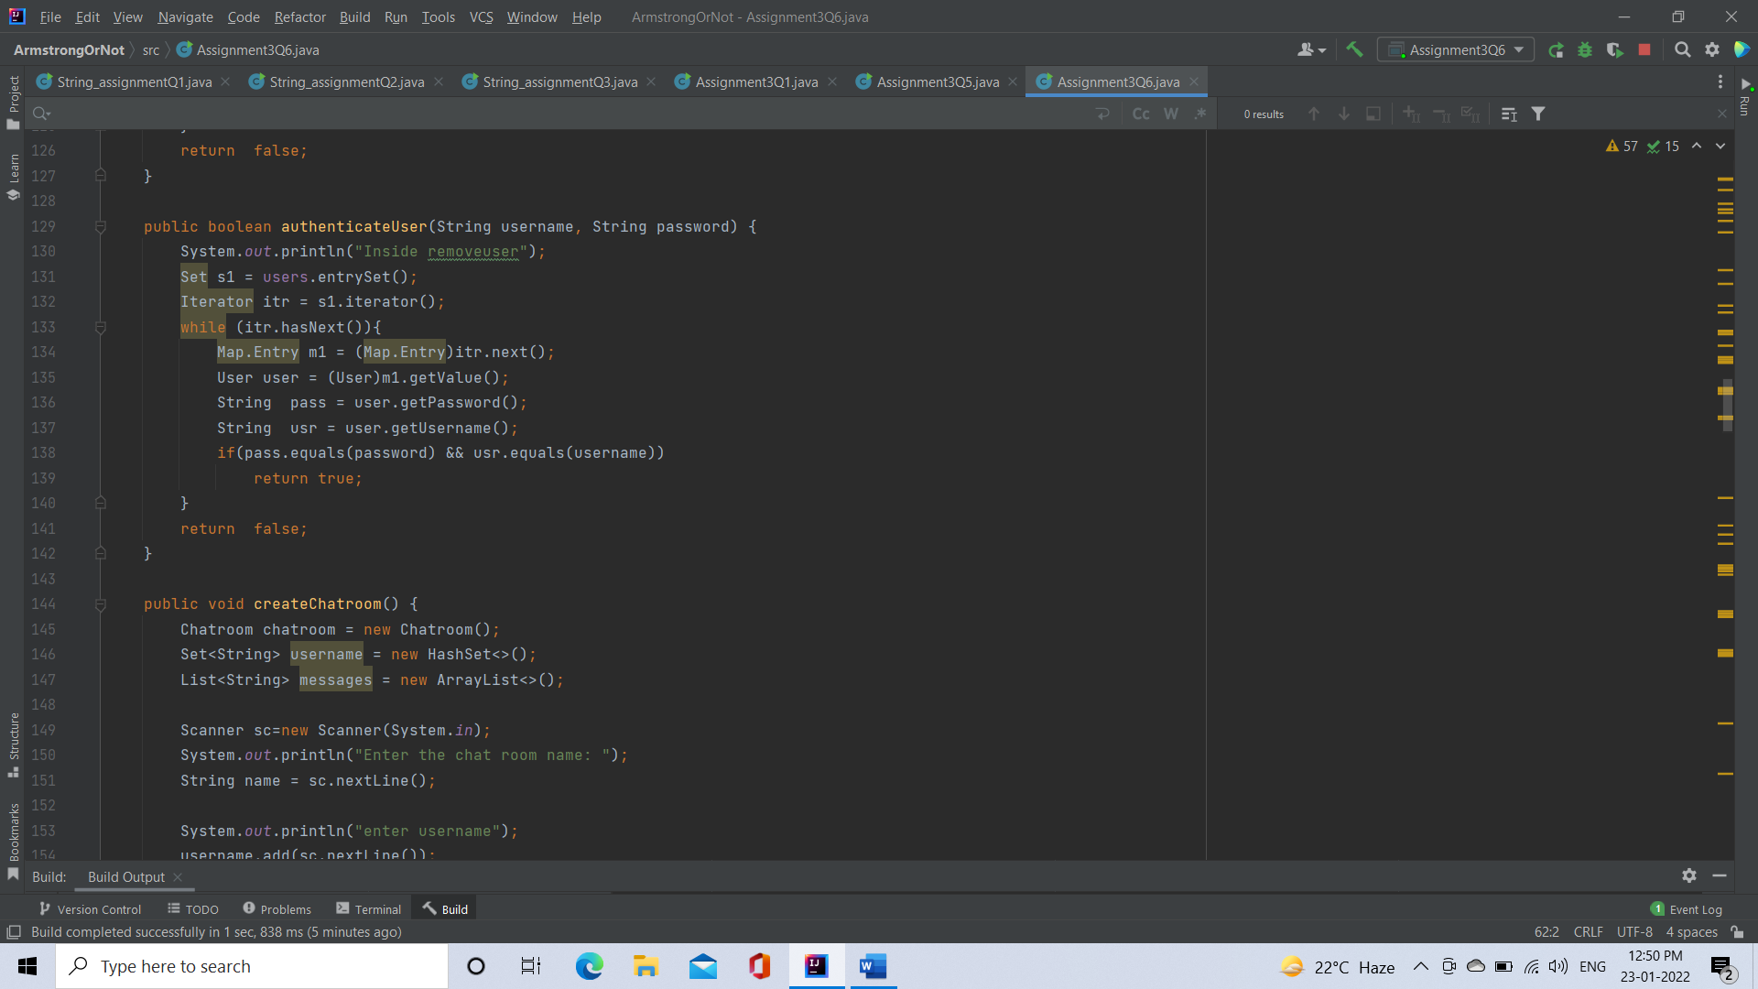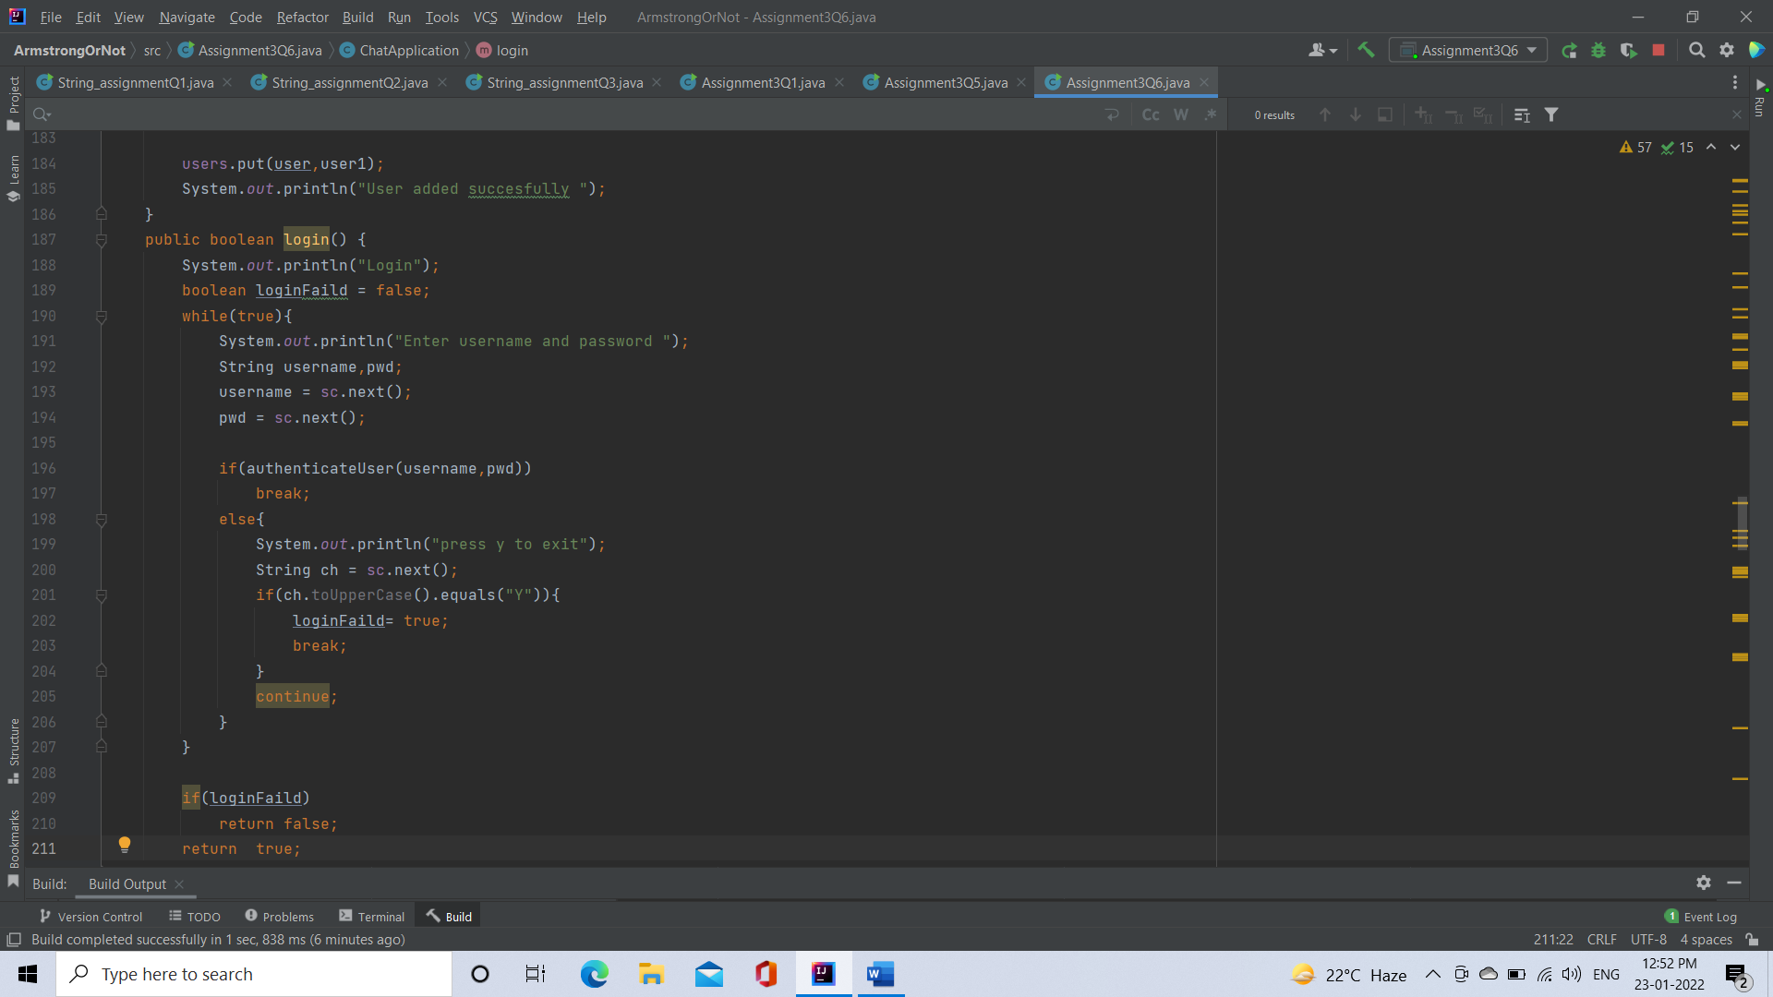

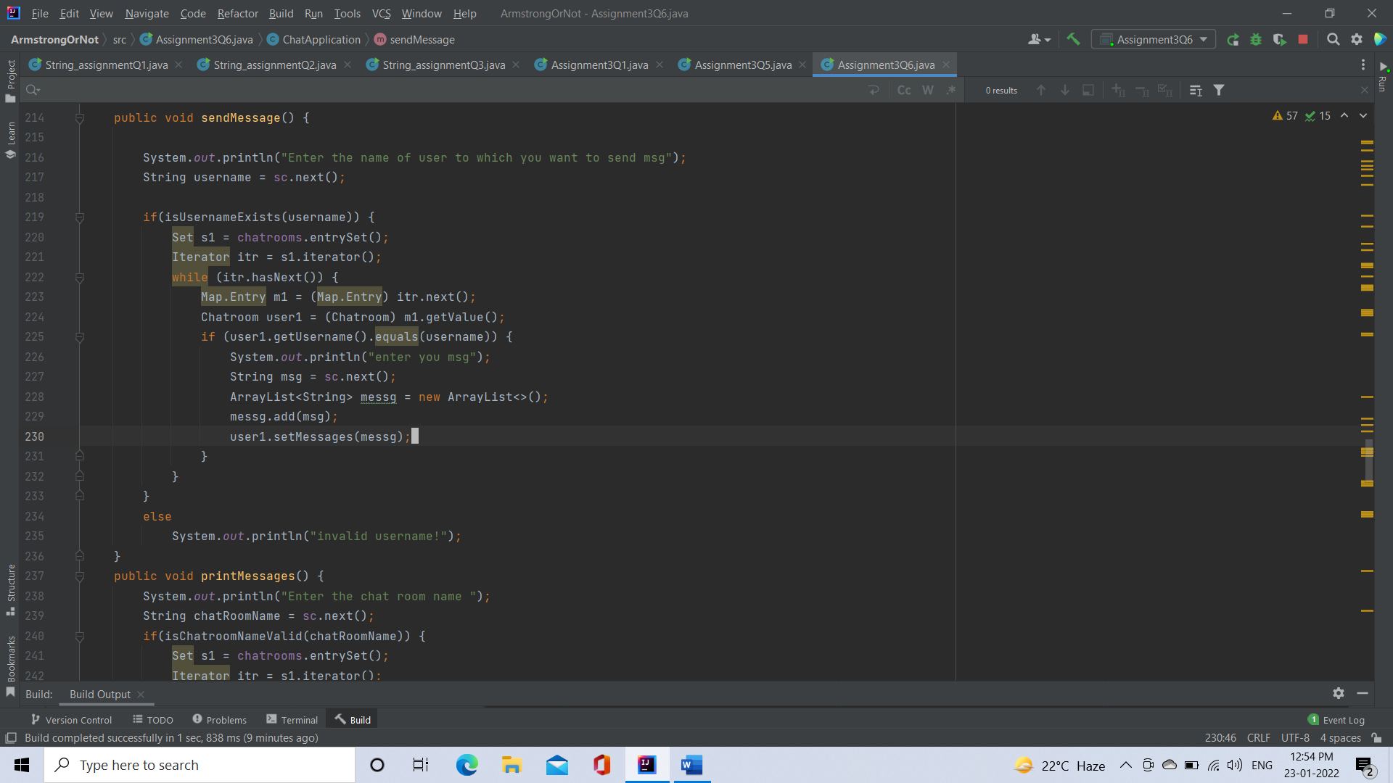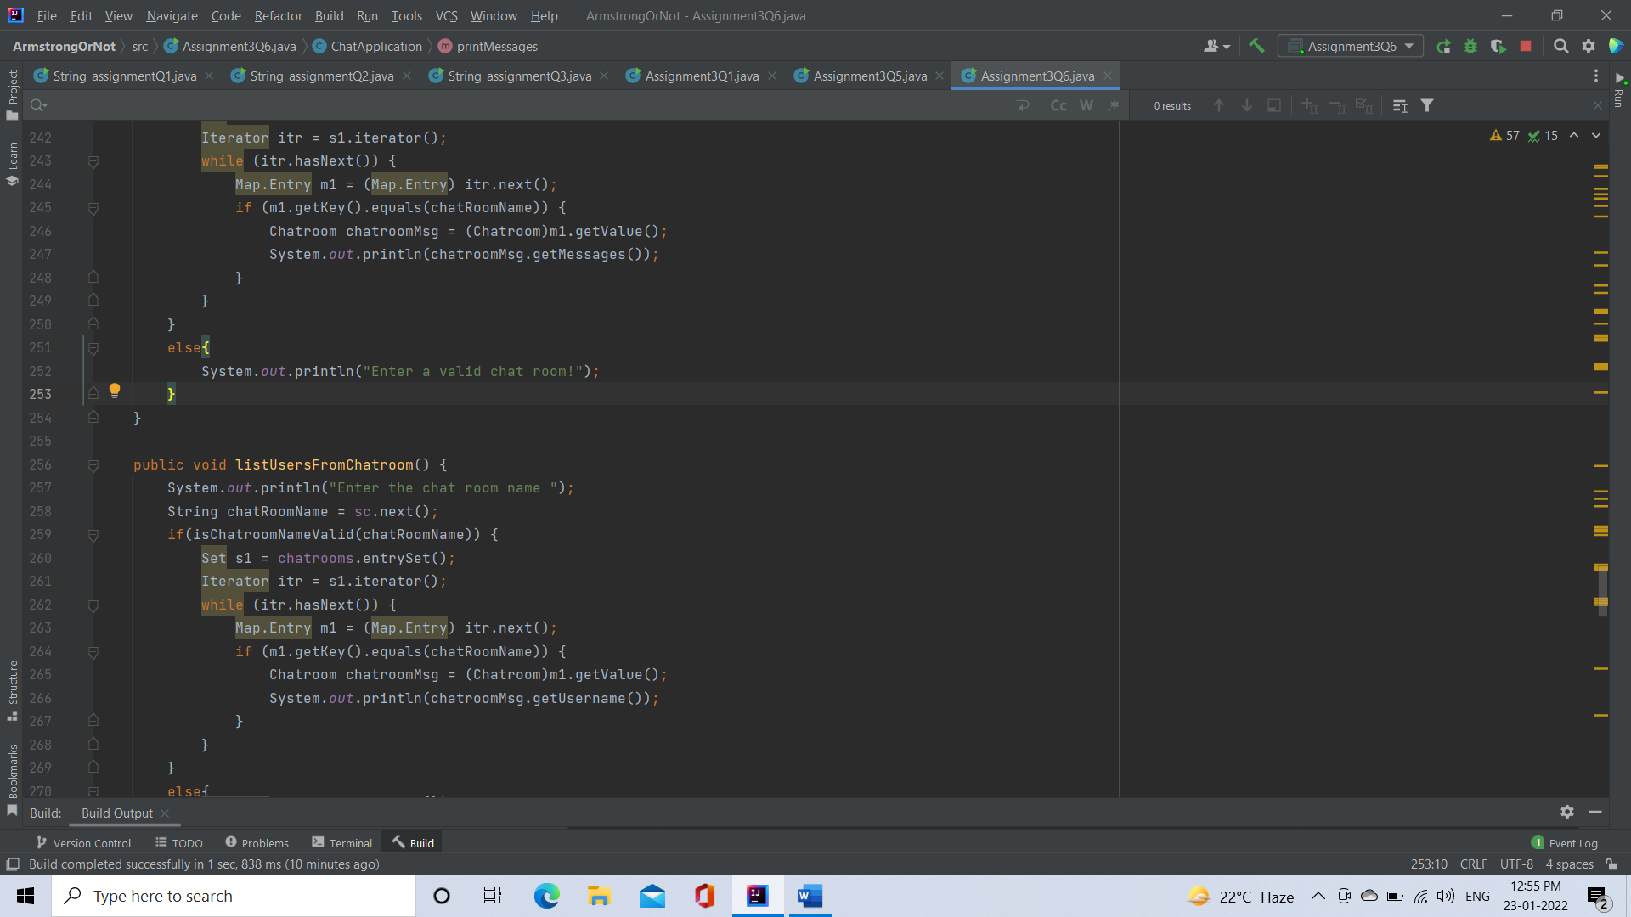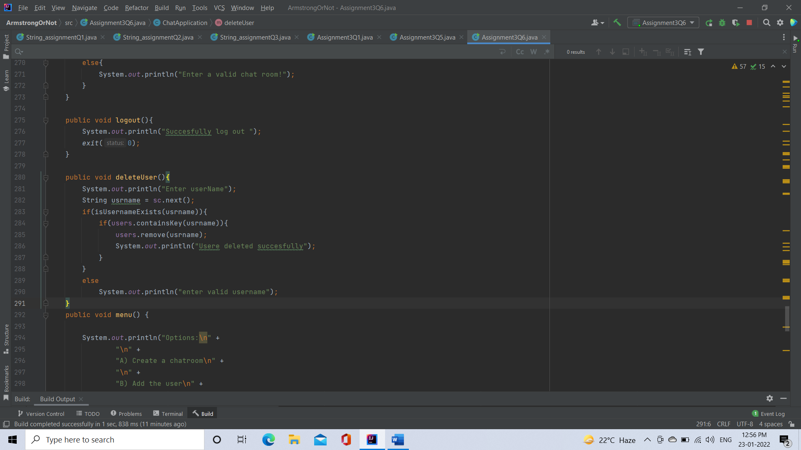

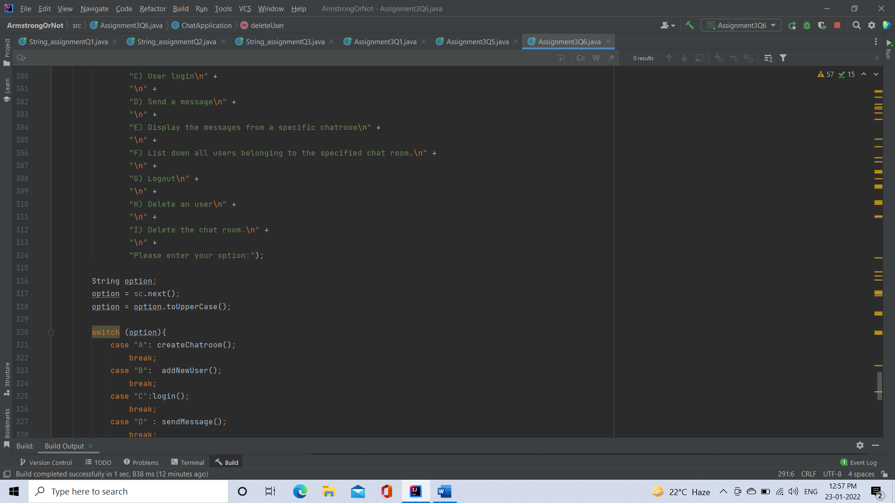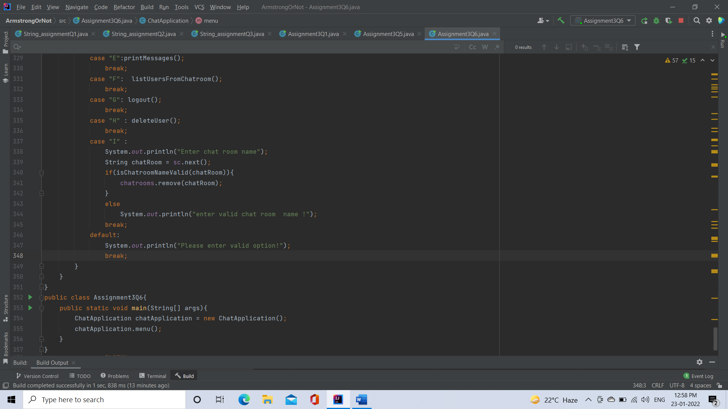

Output:

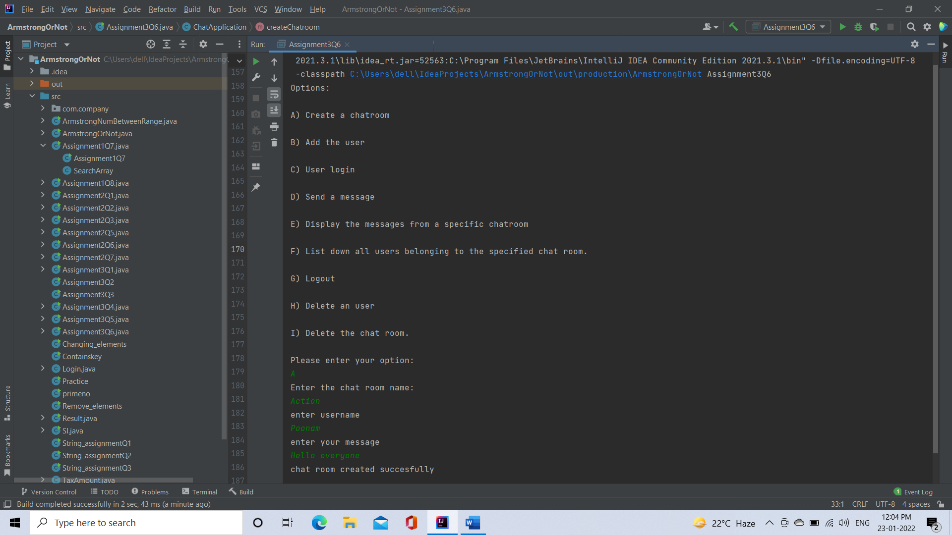

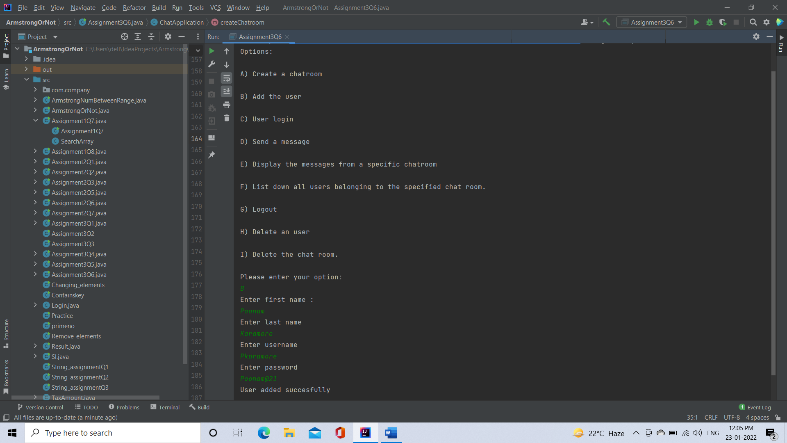

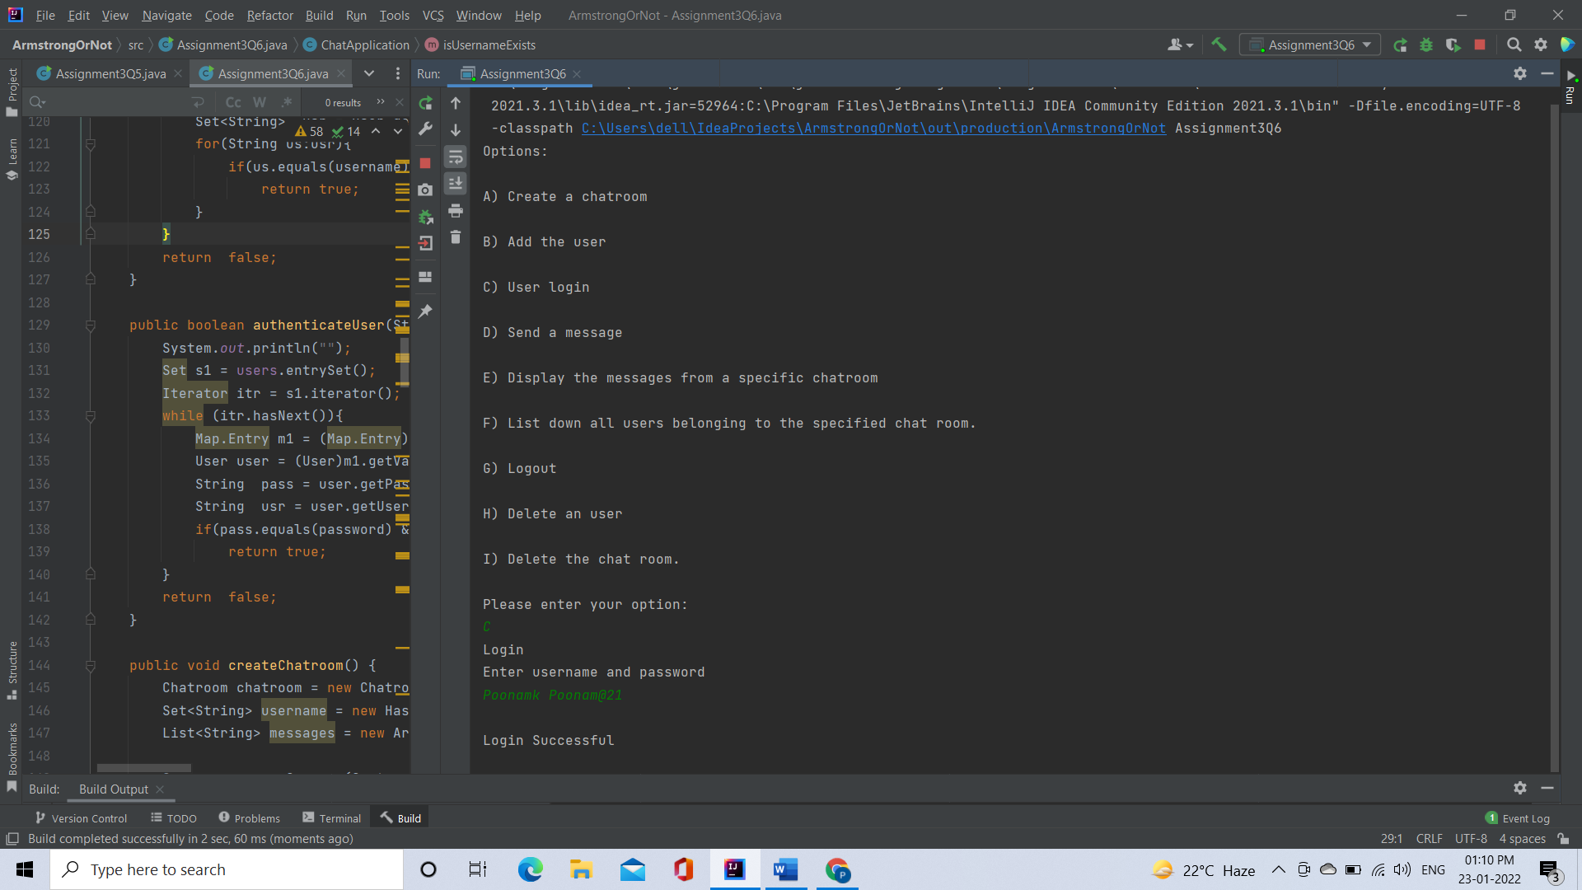

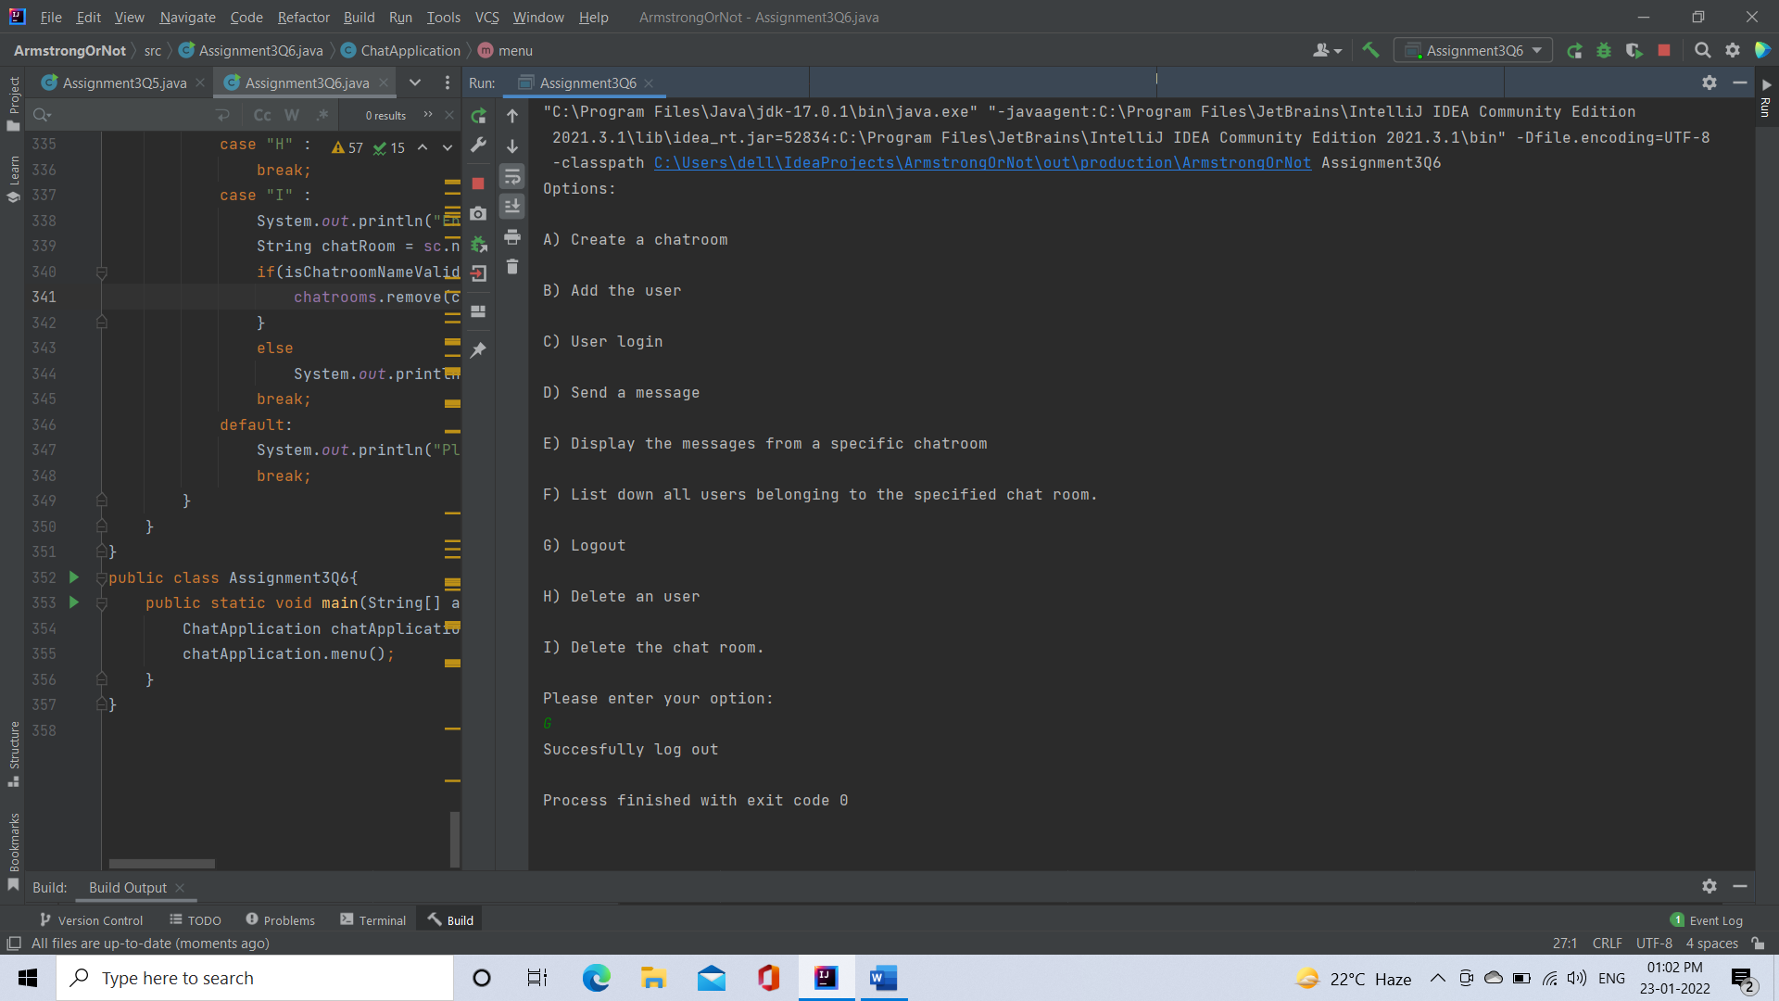

[**Q7**](https://adapt.in.capgemini.com/mod/vpl/view.php?id=2169)**. There is parking slot available in R-Mall with 3 floors; each floor has 4 sections and each section can maximum park 20 cars. You need to design one application which will maintain all car details in such way when a car owner arrives to collect his care your application should provide details including where it is located.**

**a. Create class Parked_CarOwner_Details which will have field’s owerName, carModel, carNO, owerMobileNo, owerAddress with setter and getter methods.**

**b. Create class Parked_CarOwenerList which will have method’s int add_new_car(Parked_CarOwner_Details obj), remove_car(), get_parked_car_location(token).**

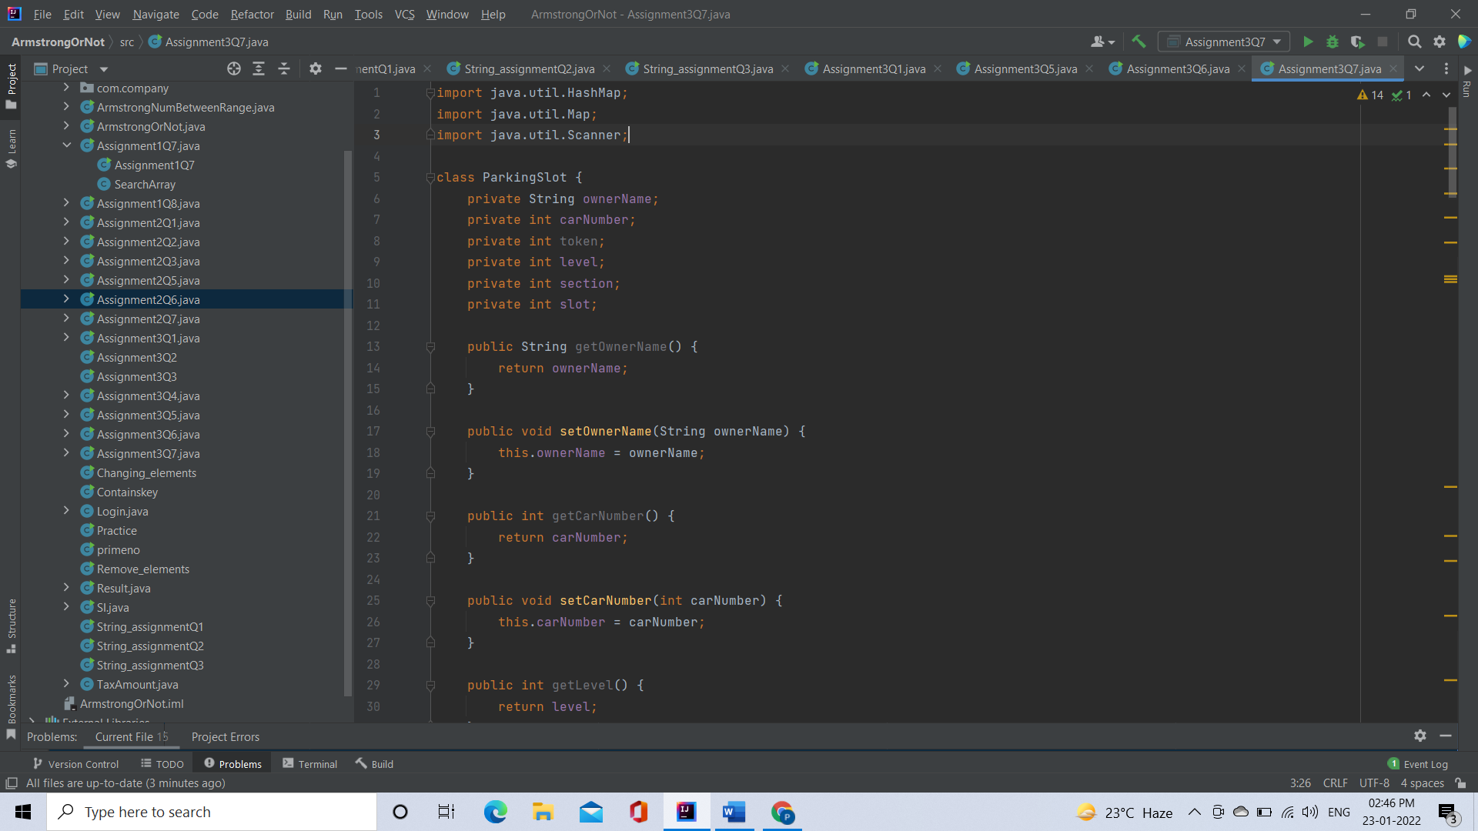

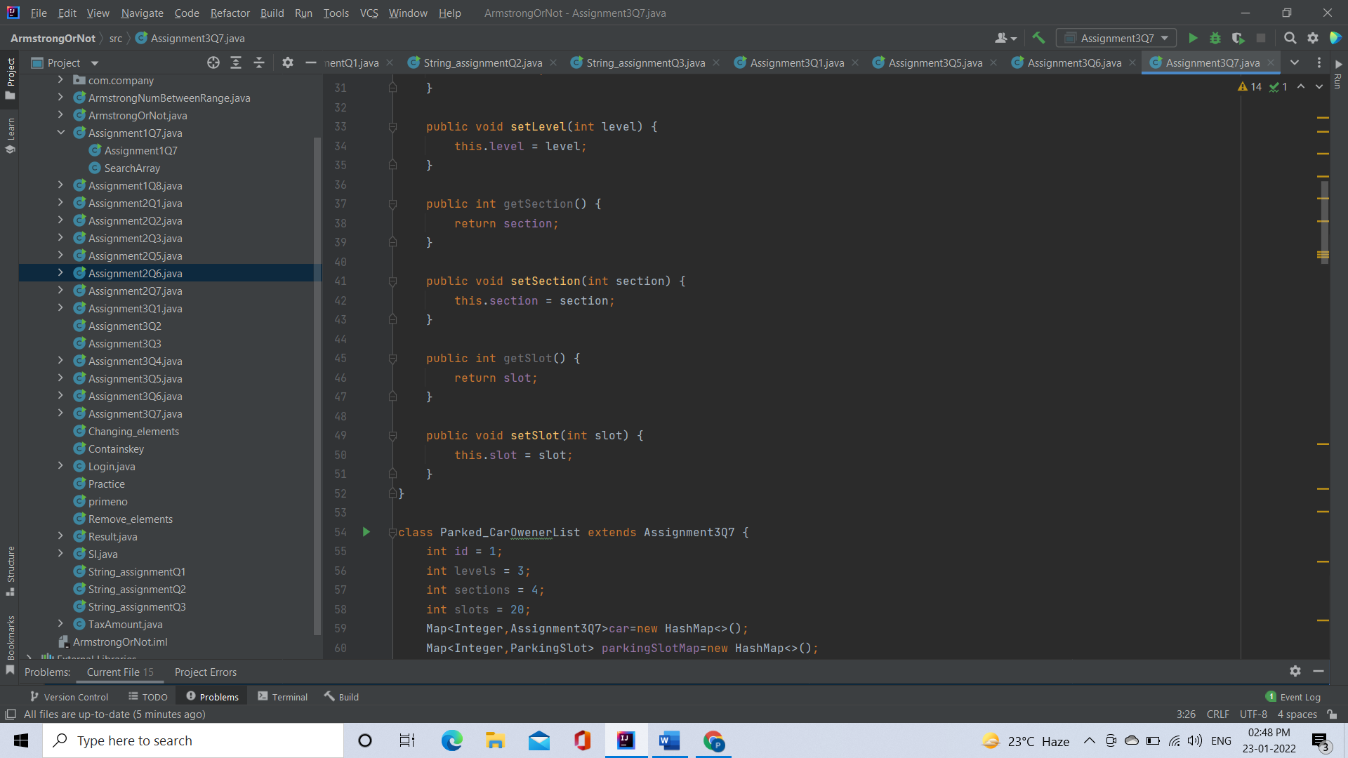

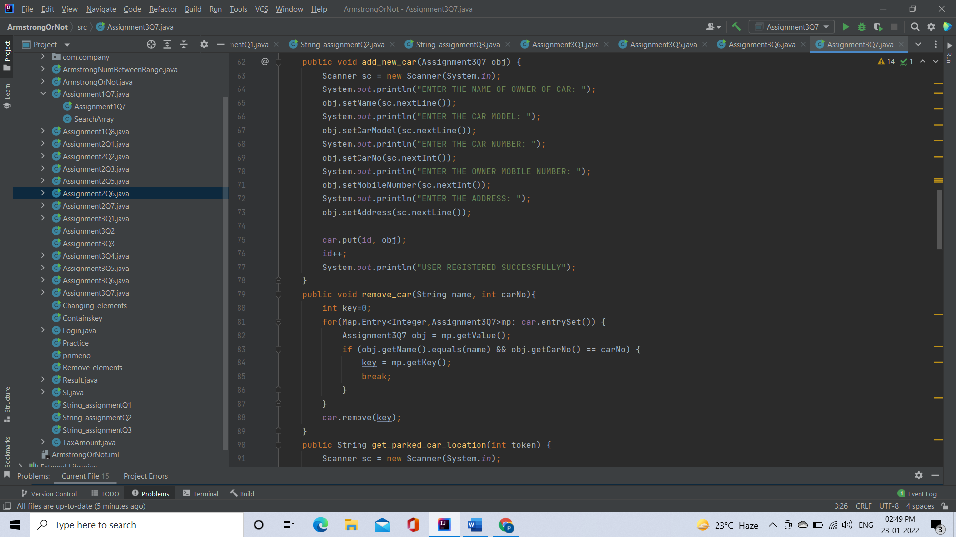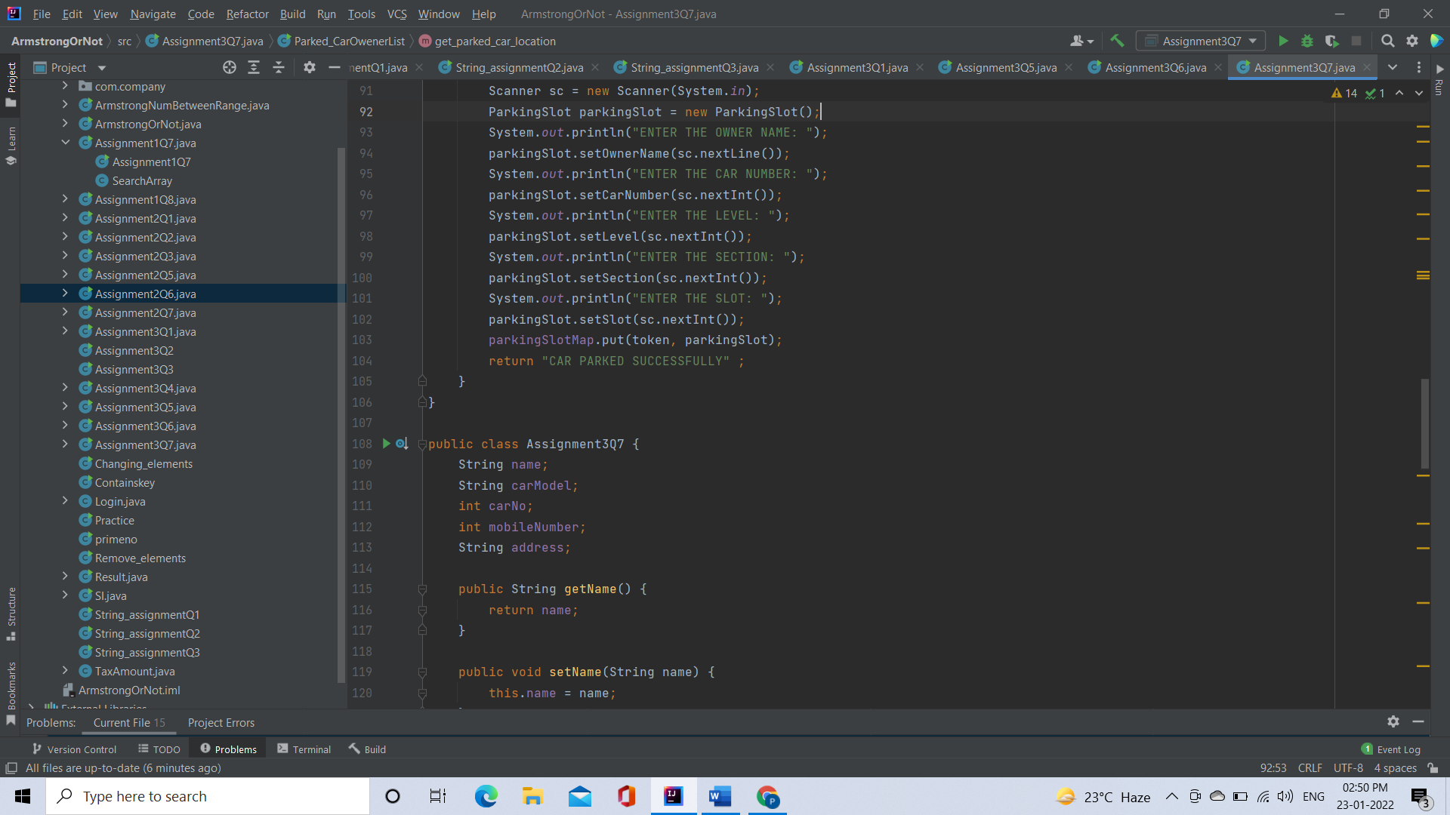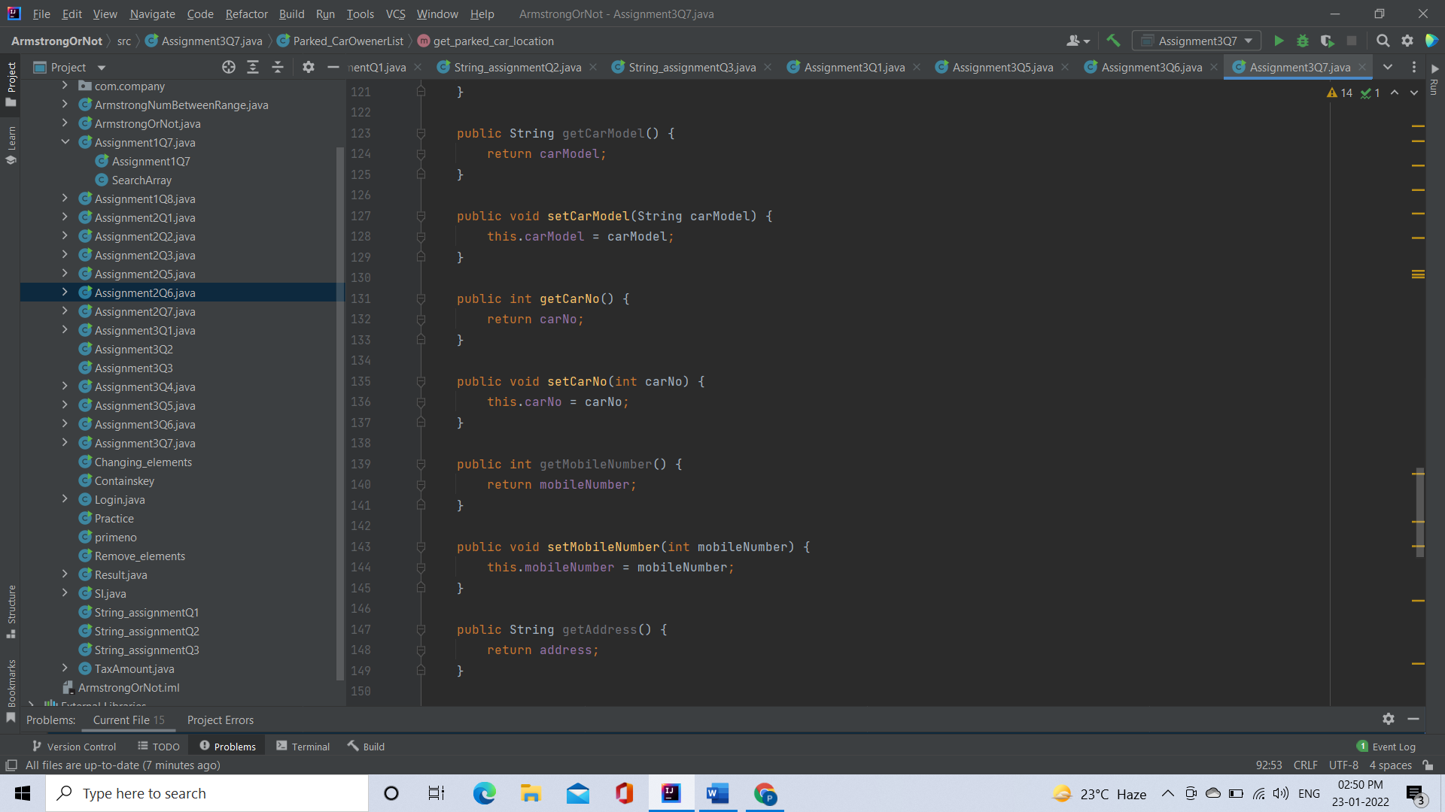

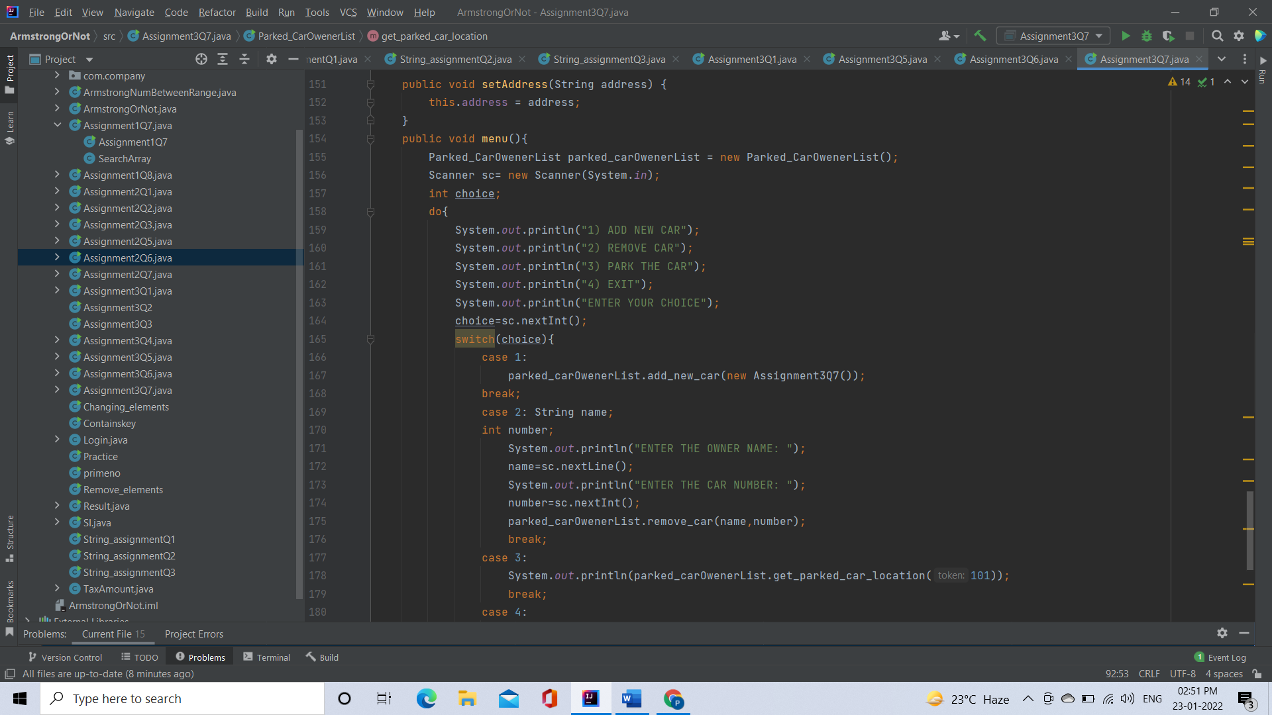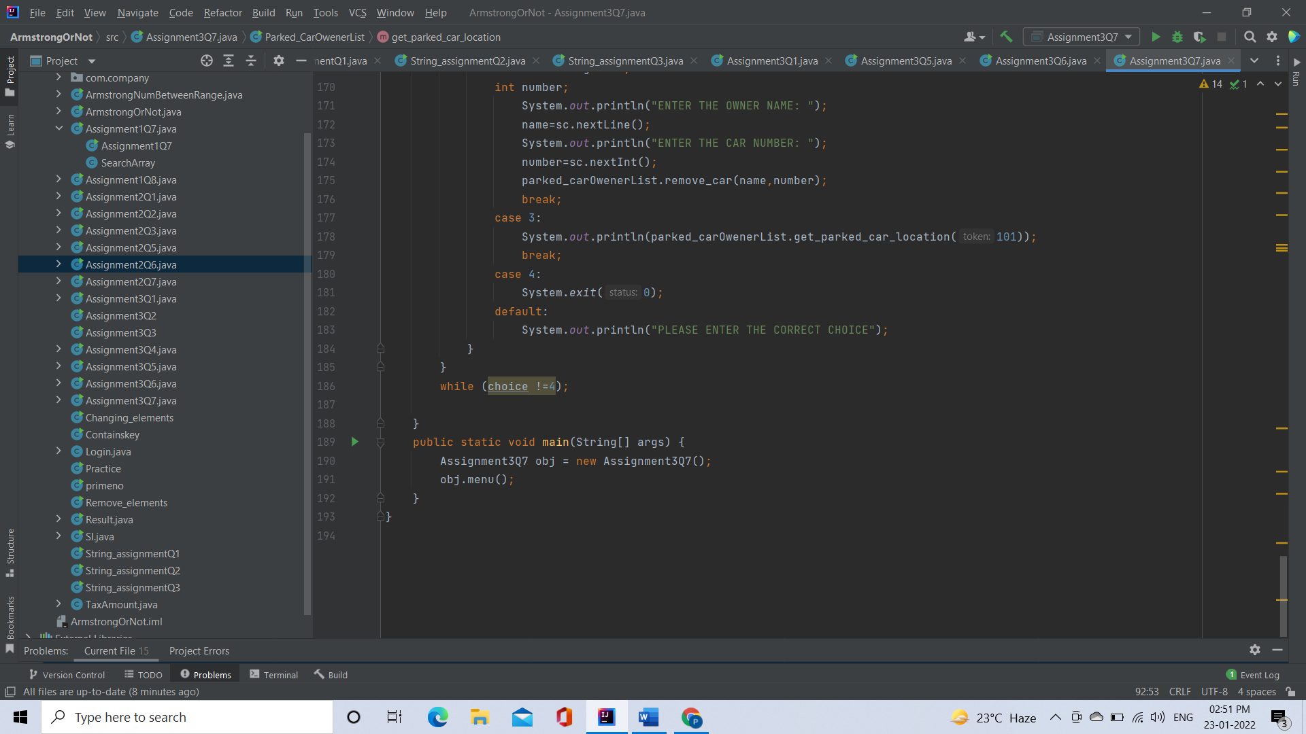

Output:

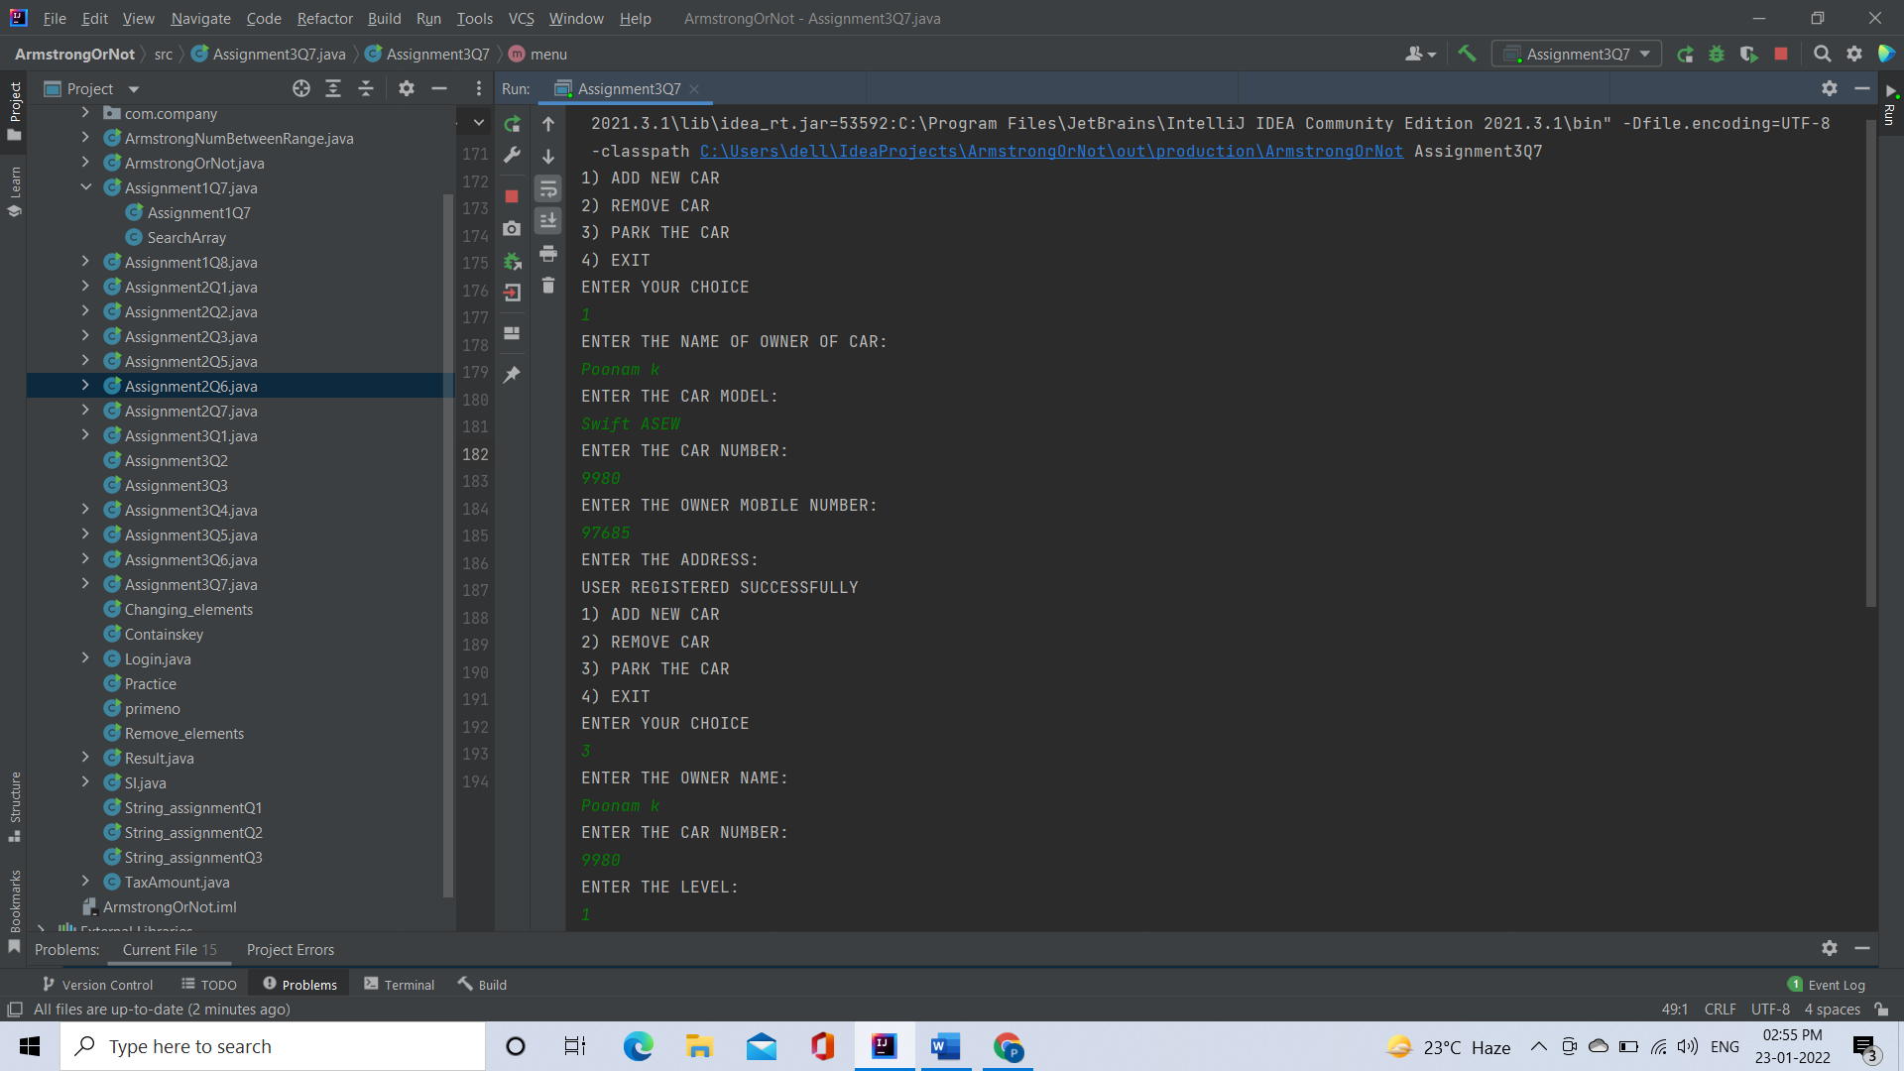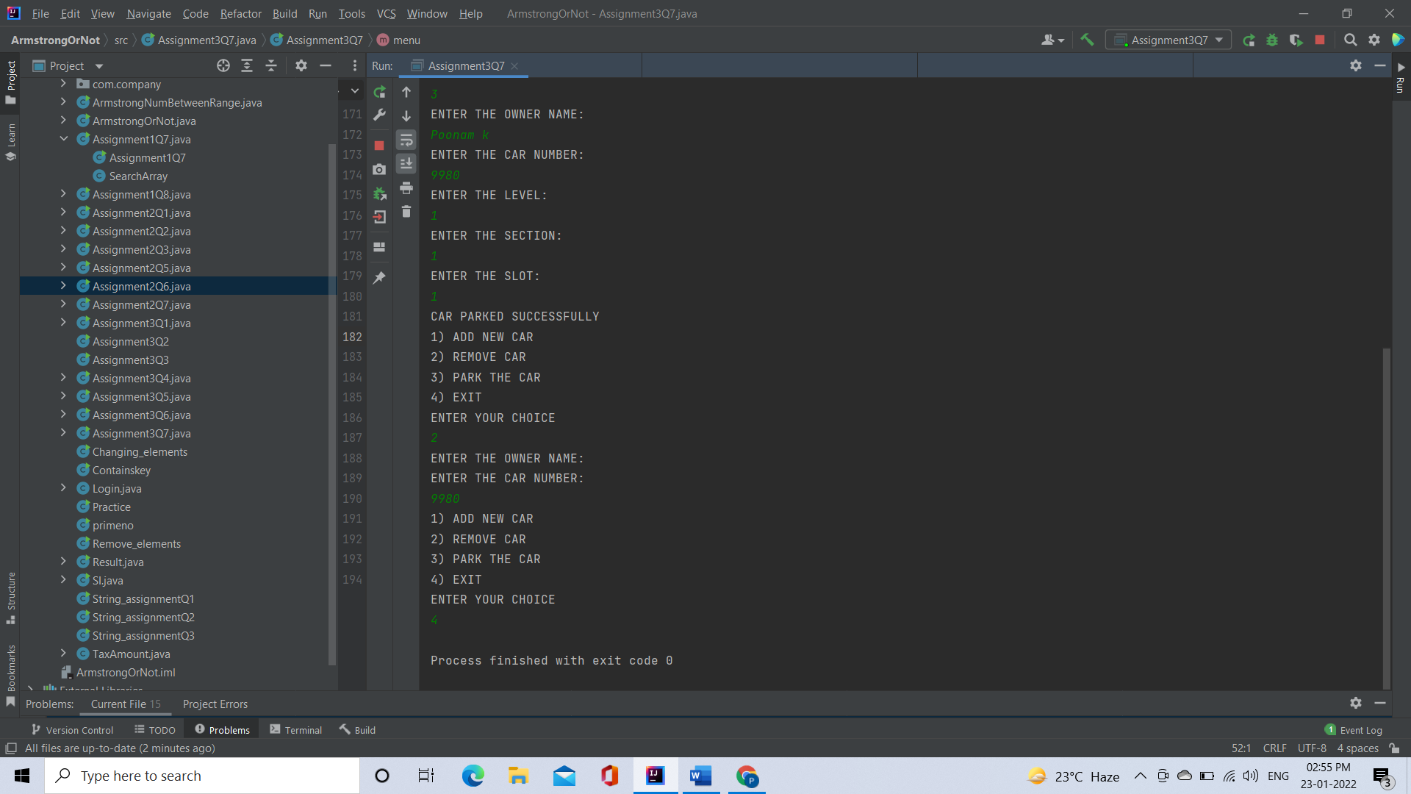

[**Q8**](https://adapt.in.capgemini.com/mod/vpl/view.php?id=2147)**.1.  Test fail-fast iterators within multithreaded environment. Note example of fail fast iterator is Vector, ArrayList, HashSet etc. And fail-safe is ConcurrentHashMap, CopyOnWriteArrayList etc.**

**Fail Fast:** Iterators in java are used to iterate over the Collection objects.Fail-Fast iterators immediately throw ConcurrentModificationException if there is structural modification of the collection. Structural modification means adding, removing or updating any element from collection while a thread is iterating over that collection. Iterator on ArrayList, HashMap classes are some examples of fail-fast Iterator.

Code:

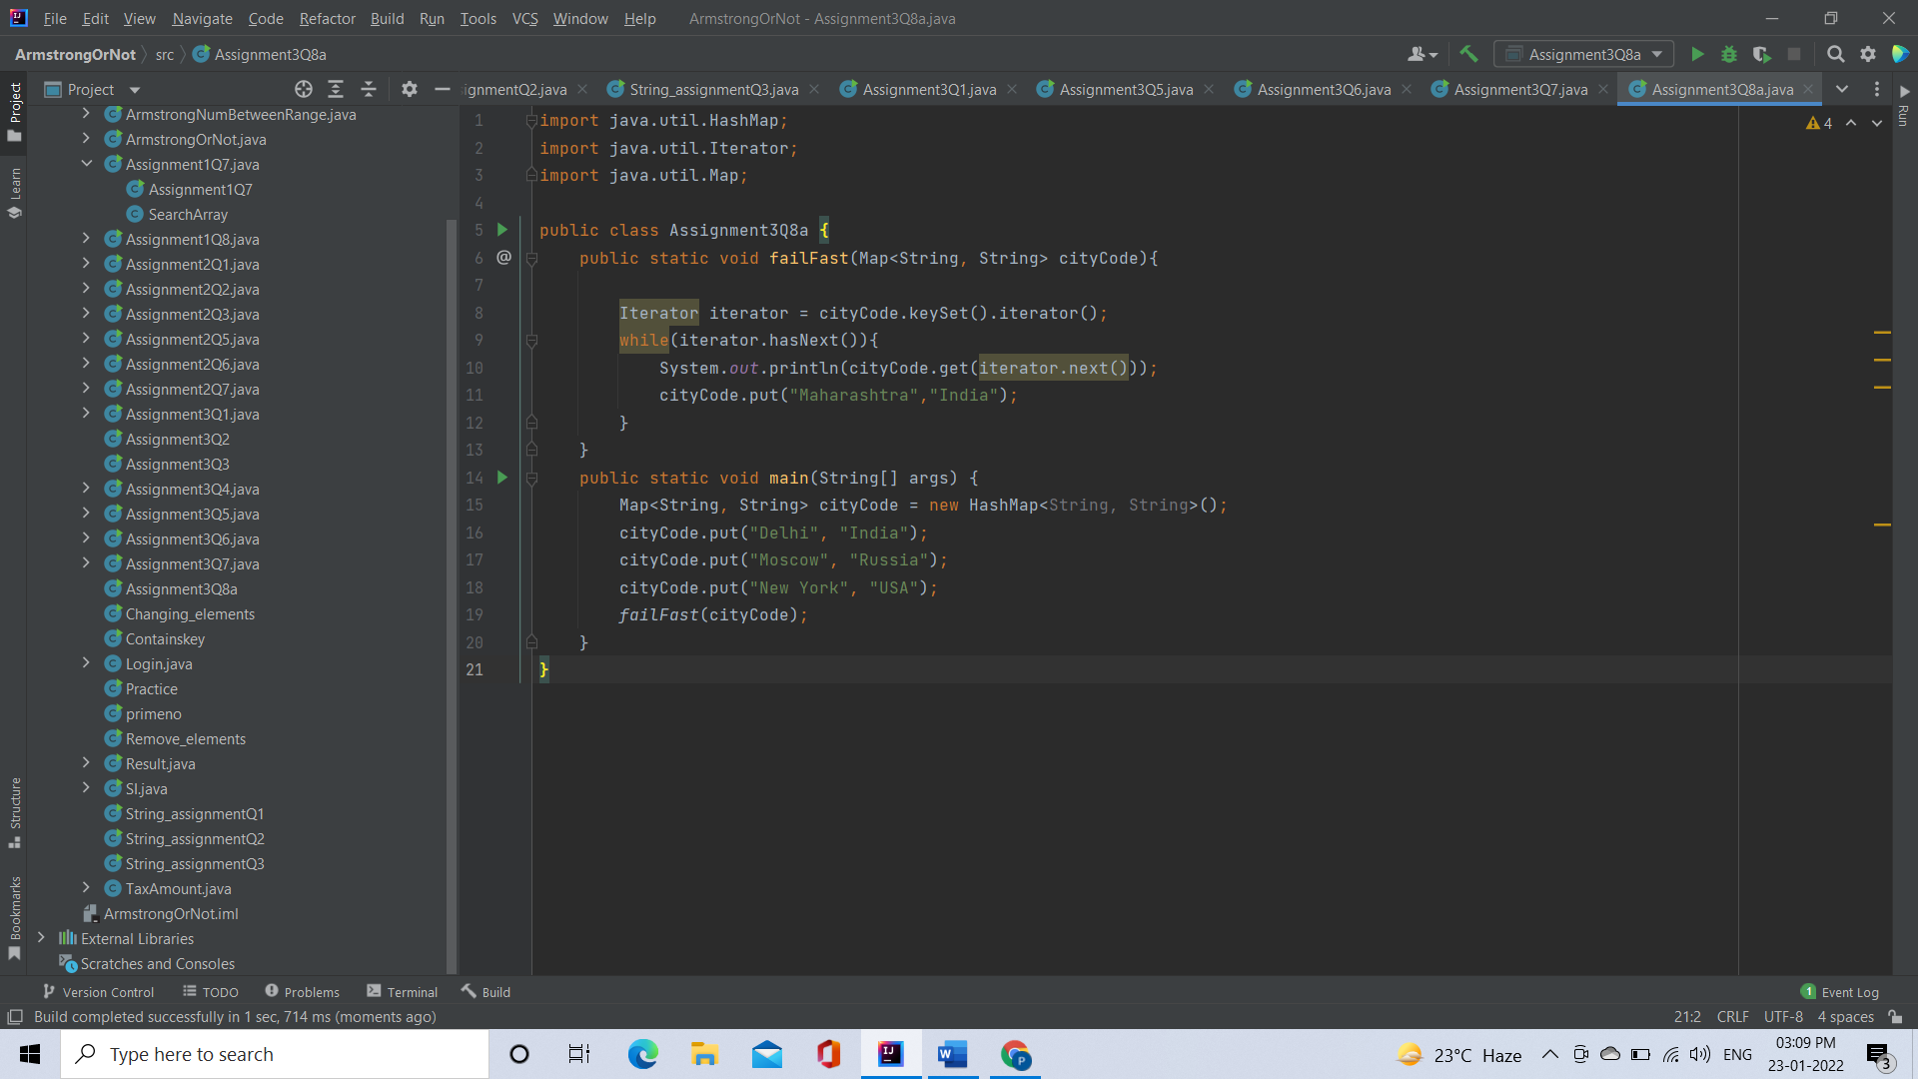

Output

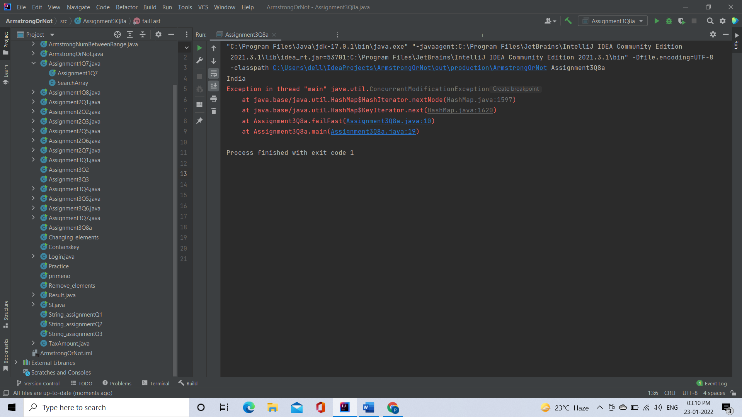

[**Q8**](https://adapt.in.capgemini.com/mod/vpl/view.php?id=2147)**.2. Test fail-safe iterators within multithreaded environment. Note example of fail fast iterator is Vector, ArrayList, HashSet etc. And fail-safe is ConcurrentHashMap, CopyOnWriteArrayList etc.**

**Code:**

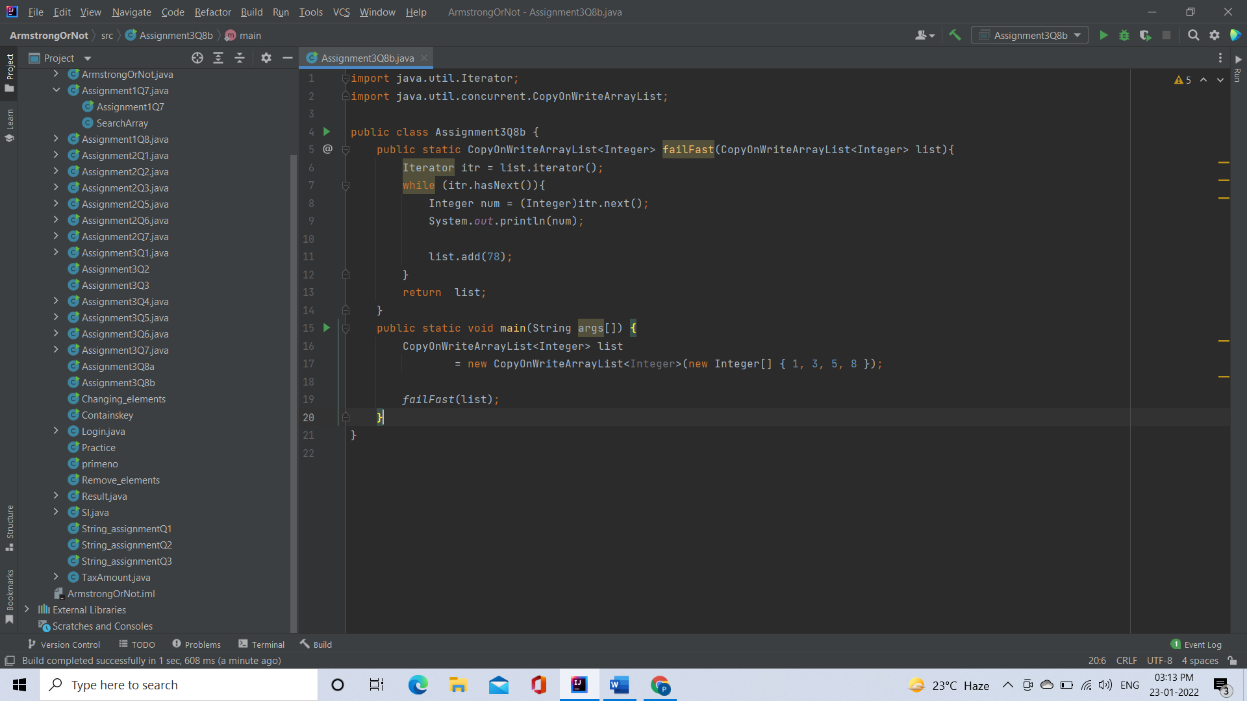

**Output:**

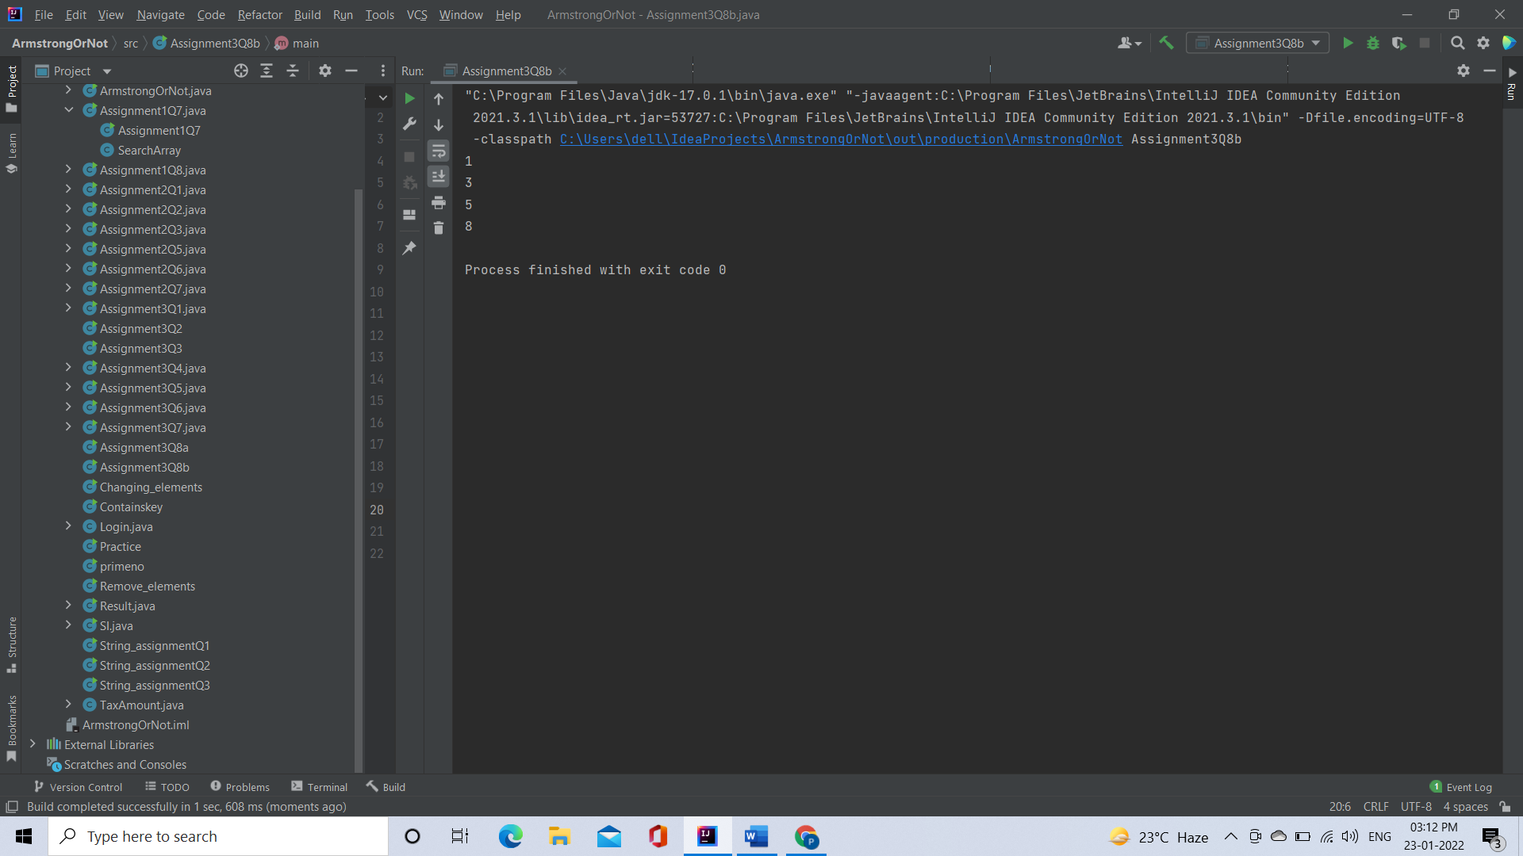

[**Q9**](https://adapt.in.capgemini.com/mod/vpl/view.php?id=2150)**. Create a Class SavingAccount with field’s acc_balance, acc_ID, accountHoldername, isSalaryAccount. Also add setter and getter methods with business method like withdraw and deposit.**

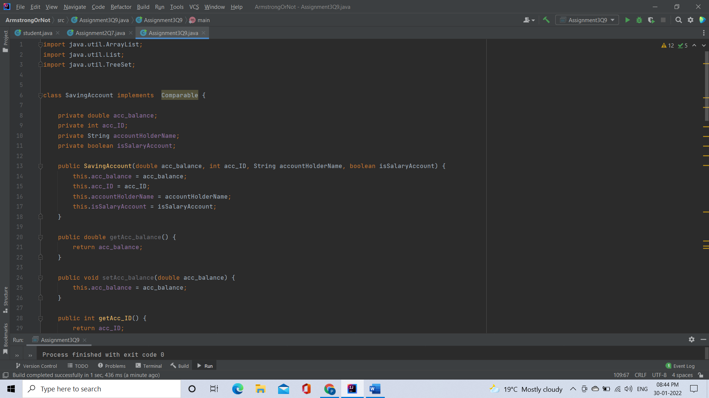

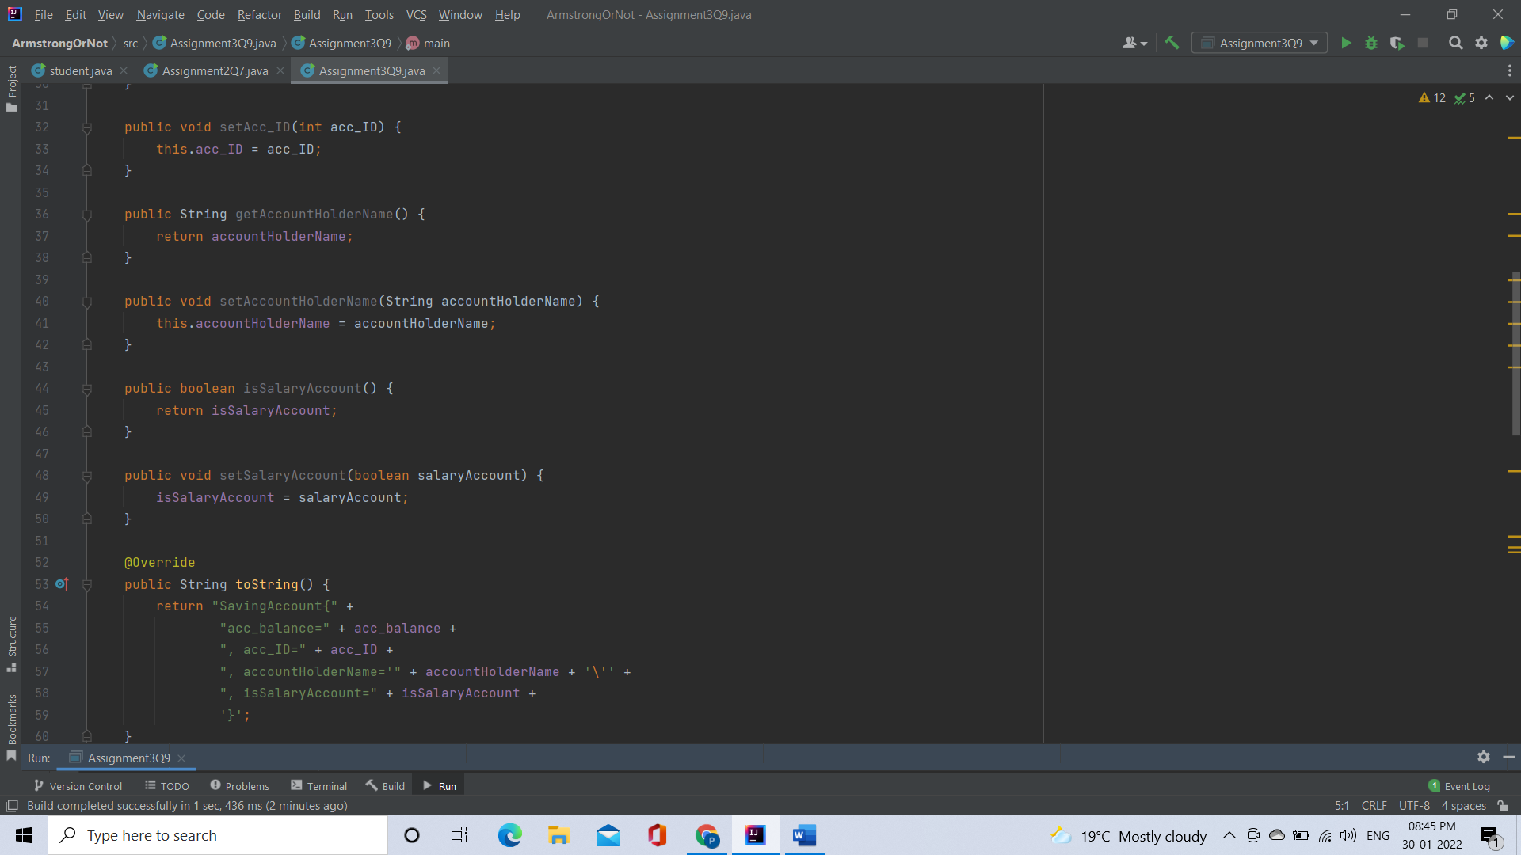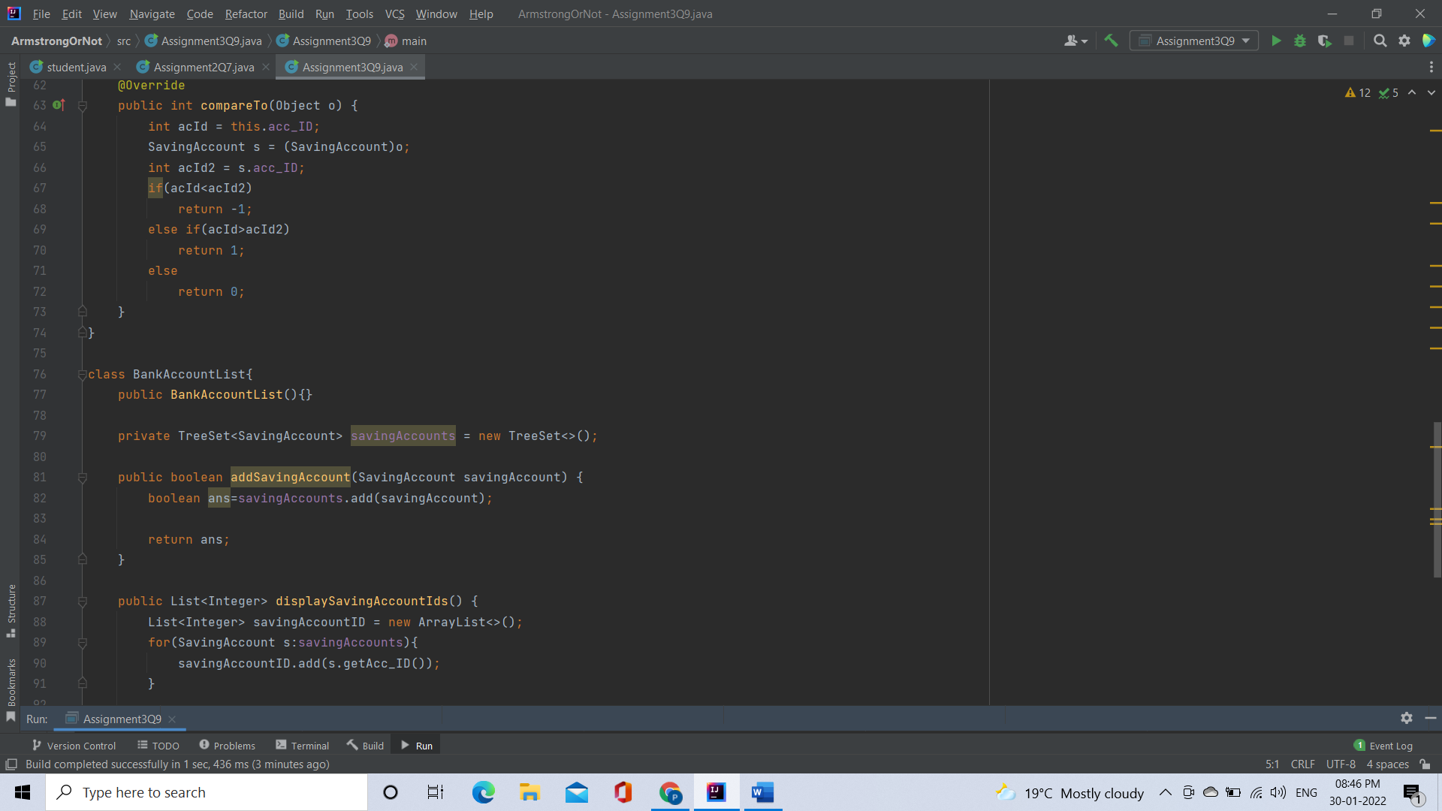

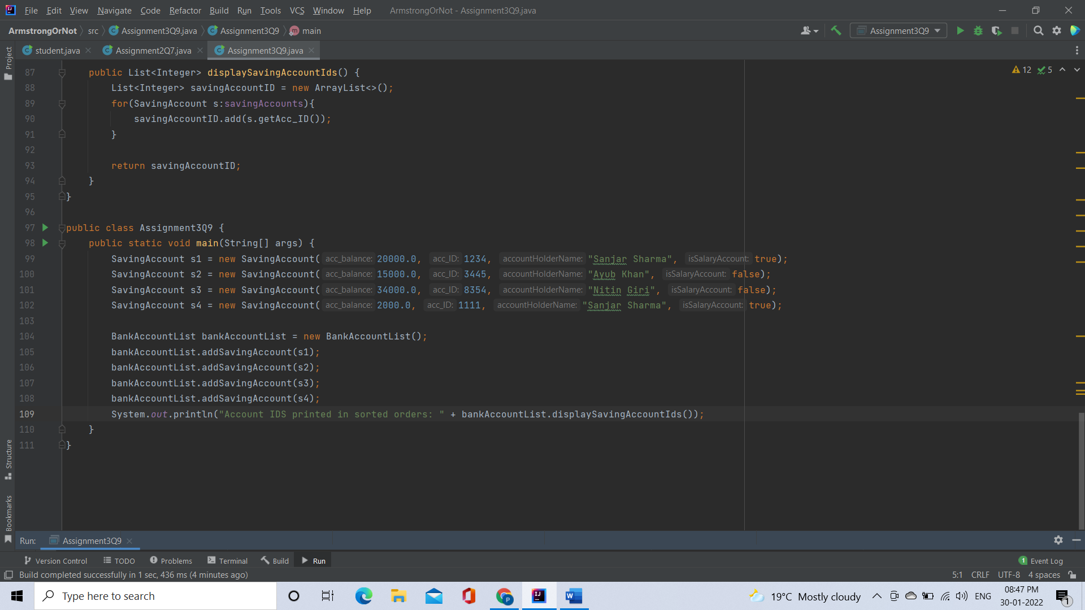

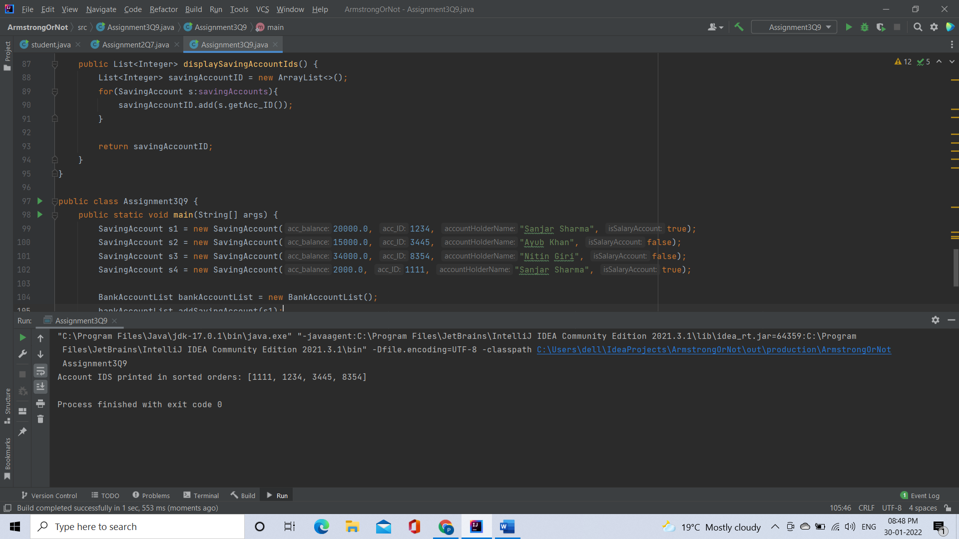

**Q10. Create class Movie_Details with field’s mov_Name, lead_actor, lead_actories, and genre add setter and getter method in that class.**

**a. After creating this class create class Movie_DetailsList class who will maintain all the objects.**

**b. Movie_DetailsList class should have method add_movie(), remove_movie(), remove_AllMovies(), find_movie_By_mov_Name(), find_movie_By_Genre()**

**c. Movie_DetailsList should have method which will take an argument that will be use to determine on which to sort**

